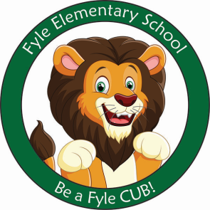

Mrs. Janofsky’s Weekly Update

February 1, 2019

ELA

A popular unit in Kindergarten is our Author Study. We will be reading and discussing books written and illustrated by Eric Carle. We will learn about his way of making the illustrations. Key vocabulary will be author, illustrator, character and setting. Children will learn to identify these elements of a story and will also work to understand the characteristics of a character ie., greedy, foolish. In writing, we continue to work to make sure our sentences have SWAG. Ask your child about this. This means that a sentence starts with an upper case and then has lower case, written neatly, spaces between words, and punctuation. This gets harder when writing more than one sentence.

Math

Module three has ended. The children did a great job on their assessments! Thank you for helping to practice the vocabulary of more and less. Our next unit will be addition and subtraction. Look for flashcards to come home next week with instructions for practicing. Children are expected to be fluent with both addition and subtraction facts within five.

Social Studies

This week we continued to discuss needs and wants and focused on making a choice when picking ie., milk or potato chips. We are also enjoyed learning about Groundhog’s Day. We had fun watching videos of the groundhog and learning about a real one.

Important Information

* Specials after break:
  + Monday: D
  + Tuesday: A
  + Wednesday: B
  + Thursday: C
  + Friday: D
* Library on Wednesday. Please help your child remember their book!
* February Break: No School the week of February 18th.
* Sight word bags will be updated next week
* **Progress Reports are in today’s folder. Please sign and return the slip and envelope on Monday.** Contact me with any questions. I am VERY proud of them all.

Sight Words

look

Valentine’s Day

At Fyle, we call this day Caring Day. A note with all the details will come home next week. Children may bring in cards. I am asking that they only sign them and do NOT address them to a specific child. We have 16 students and one should be brought for each person.