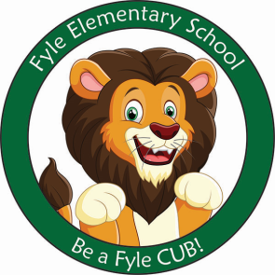

Mrs. Janofsky’s Weekly Update

November 9, 2018

ELA

This week we sequenced pictures to go with the nursery rhyme “Hickory Dickory Dock.” We also learned “Star Light Star Bright.” Our Fundations letters of the week were p and j. We only have a few letters left. The expectation right now is that they would know all of these letters and their sounds. The children are beginning to “stretch words” to record more dominant sounds in words. At home, it is important that they practice saying words they want to write for themselves. Please accept their “kid spellings” of words. It is important that the children practice this way of writing.

Math

Our second math unit is a short unit on shapes. The unit reviews the names of the shapes. The children are working to explain how they know what a shape is ie., It is a triangle because it has three corners and three straight sides. Look for shapes around you wherever you are ie., at the grocery store.

Social Studies

This week we have been learning about Veteran’s Day. Please ask your child to tell you what they have learned.

Important Information

* Next week’s letter schedule:
  + Monday: No School
  + Tuesday: D
  + Wednesday: A
  + Thursday: B
  + Friday: C
* Library on Wednesday. Please help your child remember their book!
* Important Reminder! The children will be going outside for recess on days it doesn’t rain. Please be sure your child has hats and mittens as the weather changes.
* Please help your child practice putting their coat on, turning sleeves the right way, and zipping it.
* Upcoming dates:
  + November 14-picture retakes and Parent Group Meeting
  + November 19 and 20-Parent Teacher Conferences.
  + No School the week of November 19th.

Sight Word

We

Sight Word Bags

Just a reminder that sight word/letter bags should be kept in your children’s folders. Bags are currently being updated. The children did a great job learning the words, letters, and numbers on their cards. THANK YOU FOR YOUR HELP!!!!!!