Mr. Kuhn

AP Language & Composition

Rush-Henrietta Senior High School

kkuhn@rhnet.org

Kristian_kuhn75@yahoo.com

359-5200 ext. 1125 or voicemail 1826

**AP Language & Composition**

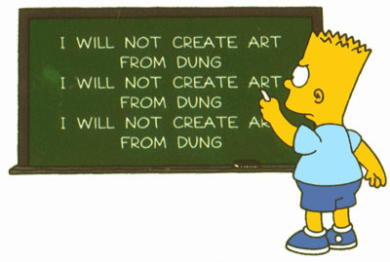

**Words of Wisdom**

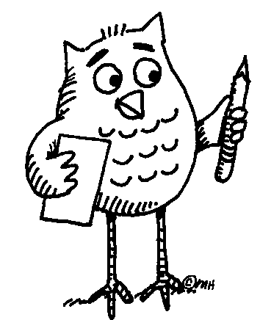

- A man ought to read just as inclination leads him; for what he reads as a task will do him little good.

**Samuel Johnson**

- There's no such thing as writer's block. That was invented by people in California who couldn't write.  
 **Terry Prachett**

- People say that life is the thing, but I prefer reading.

**Logan Pearsall Smith**

- I believe more in the scissors than I do in the pencil. **Truman Capote**

**-** The difference between the right word and the almost right word is the difference between lightning and a lightning bug.

**Mark** **Twain**

**- Well, we committed 24 errors, and their pitcher threw a no hitter against us, but there is some good news! Two of our runners almost managed to get to first base, and we did hit seventeen foul balls!  
 Ogilvie from *The Bad News Bears***

**Course Overview**

The purpose of this course is to provide competent, motivated students an opportunity to do college-level work in high school. Successful college students read and respond to a variety of academic and professional texts. The primary focus of AP English Language and Composition at Sperry High School is to develop college-level, nonfiction reading skills and demonstrate these skills principally through writing. College-level reading is intellectually demanding in respect to both quantity and quality – that is, qualitatively challenging readers with sophisticated and specialized vocabularies and sentence and text structures. In that students read (and reread) lengthier and more difficult texts than they have encountered in the past, determination and a committed work ethic are necessary components for success in this course and students are expected to spend a considerable amount of time reading and writing outside of class each day. While this course is challenging, we trust that our students’ diligence and active engagement with classroom instruction and discussions will measurably improve their academic skills by the end of the course.

The readings for this course have been selected because they are representative of a variety of voices and perspectives. Beyond engagement with a diversity of subject matters, this course emphasizes the ways in which writers achieve their purposes, connect with and persuade their audiences through adroit use of rhetorical and literary elements. Students identify, analyze, and evaluate these features in texts drawn from numerous genres, including the essay, autobiography, biography, history, criticism, journalism, correspondence, oration, and fiction together with ancillary genres and sub-genres. From the study of these communicative forms, students improve their ability to read closely, ascertain meaning, articulate rhetorical strategies, and evaluate communicative effectiveness and argumentative cogency.

To aid students in effectively interacting and engaging with texts, students respond to course readings in writing, both formal and informal. Student writing skills are analyzed, assessed and improved through guided and independent practice along with peer collaboration. Writing conferences and seminars accompany every formal writing assignment, facilitating collaboration in the brainstorming, outlining, and editing.

**Learning Objectives**

Upon completing the AP Language & Composition course, students should be able to:

Analyze and interpret samples of good writing, identifying and explaining an author’s use of rhetorical strategies and techniques;

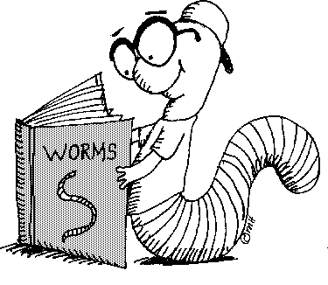

Apply effective strategies and techniques in their own writing;



Create and sustain arguments based on readings, research, and/or personal experience;



Demonstrate understanding and mastery of standard written English as well as stylistic maturity in their own writings;



Write in a variety of genres and contexts, both formal and informal, employing appropriate conventions;



Produce expository, analytical, and argumentative compositions that introduce a complex central idea and develop it with appropriate evidence drawn from source material, cogent explanations, and clear transitions;



Move effectively through the stages of the writing process with careful attention to inquiry and research, drafting, revising, editing, and review;



Revise a working composition;



Analyze images as text;



Move effectively through the stages of the writing process with careful attention to inquiry and research, drafting, revising, editing, and review.



**The Literature (Note: This is a list of representative authors – many of whom we’ll tackle)**

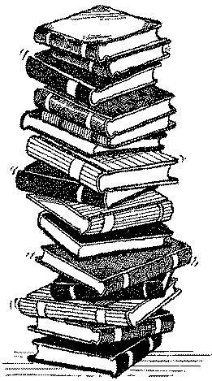

**Autobiographers & Diarists**

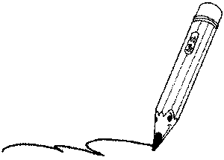

Melba Patillo Beals, James Boswell, Judith Ortiz Cofer, Jill Ker Conway, Thomas DeQuincey, Frederick Douglass, Benjamin Franklin, Stephanie Elizondo Griest, Elva Trevino Hart, Hariet Jacobs, Helen Keller, Maxine Hong Kingston, T.E. Lawrence, Frank McCourt, Samuel Pepys, Richard Rodriguez, Richard Wright, Malcolm X, Anzia Yezierska

**Biographers & History Writers**



Lerone Bennett Jr., James Boswell, Thomas Carlye, Winston Churchill, Vine Deloria Jr., Leon Edel, Richard Ellmann, Niall Ferguson, Shelby Foote, John Hope Franklin, Antonia Fraser, Edward Gibbon, Richard Holmes, Gerda Lerner, Thomas Macaulay, Francis Parkman, Arnold Rampersad, Simon Schama, Arthur Schlesinger, Ronald Takaki, George Trevelyan, Barbara Tuchman, Laura Thatcher Ulrich

**Critics**



Paula Gunn Allen, Gloria Anzaldua, Michael Arlen, Matthew Arnold, Sven Birkets, Susan Bordo, Judith Butler, Kenneth Clark, Samuel Taylor Coleridge, Arlene Croce, Ralph Waldo Emerson, Henry Louis Gates Jr., William Hazlitt, Christopher Hitchens, bell hooks, Samuel Johnson, Pauline Kael, Joyce Carol Oats, Walter Pater, John Rushkin, Edward Said, George Santayana, George Bernard Shaw, Susan Sontag, Cornell West, Oscar Wilde, Edmund Wilson

**Essayists & Fiction Writers**



Joseph Addison, James Agee, Margaret Atwood, Francis Bacon, James Baldwin, G.K. Chesterton, Joan Didion, Ralph Waldo Emerson, Paul Fussell, Mavis Gallant, Nadine Gordimer, Elizabeth Hardwick, Edward Hoagland, Zora Neale Hurston, Barbara Kingsolver, Jamaica Kincaid, Charles Lamb, Philip Lopate, Norman Mailer, Nancy Mairs, Mary McCarthy, N. Scott Momaday, Michel de Montaigne, V.S. Naipaul, Geoffrey Nunberg, Tillie Olsen, George Orwell, Cynthia Ozick, Francine Prose, Ishmael Reed, Adrienne Rich, Mordecai Richler, Sharman Apt Russell, Scott Russell Sanders, David Sedaris, Richard Selzer, Leslie Marmon Silko, Richard Steele, Shelby Steele, Henry David Thoreau, John Updike, Alice Walker, Eudora Welty, E.B. White, Terry Tempest Williams, Virginia Woolf

**Journalists**



Roger Angell, Dave Berry, David Brooks, Maureen Dowd, Elizabeth Drew, Nora Ephron, M.F.K, Fisher, Frances Fitzgerald, Janet Flanner, Thomas L. Friedman, Ellen Goodman, David Halberstam, John Hersey, Paul Krugman, Alex Kuczynski, Andy Logan, John McPhee, H.L. Mencken, Jessica Mitford, Jan Morris, Donald Murray, Susan Orlean, Rick Reilly, David Remnick, Red Smith, Lincoln Steffens, Paul Theroux, Calvin Tucker, Tom Wolfe

**Political Writers**



Hannah Arendt, Simone de Beauvoir, Wiliam F. Buckley, Jean de Crevecoeur, W.E.B Du Bois, Margaret Fuller, John Kenneth Galbraith, Charlotte Perkins Gilman, Chris Hedges, Thomas Hobbs, Thomas Jefferson, George Kennan, Martin Luther King Jr., Naomi Klein, Lewis Lapham, John Locke, Niccolo Machiavelli, John Stuart Mill, John Milton, Thomas More, Thomas Paine, Olive Schreiner, Jonathon Swift, Alexis de Tocqueville, Gore Vidal, George Will, Garry Wills, Mary Wollstonecraft

**Science & Nature Writers**



Edward Abbey, Diane Ackerman, Natalie Angier, Wendell Berry, Jacob Bronowski, Rachel Carson, Charles Darwin, Richard Dawkins, Daniel Dennett, Jared Diamond, Annie Dillard, Gretel Ehrlich, Loren Eiseley, Timothy Ferris, Tim Flannery, Richard Fortey, Atul Gawande, Stephen Jay Gould, Evelyn Fox Keller, Aldo Leopold, Barry Lopez, Peter Matthiessen, Bill McKibben, Margaret Mead, John Muir, Steven Pinker, David Quammen, Carl Sagan, Lewis Thomas, Jonathan Weiner, E.O. Wilson

**Assessment**

At the start of each unit you will receive a detailed syllabus outlining major assignments and my grading criteria. It is important that you spend some time familiarizing yourself with these requirements because you will be held accountable to them. Certain assignments will weigh more than others, and at the end of the unit, I will total your earned points for a final unit grade.

**Required Materials**

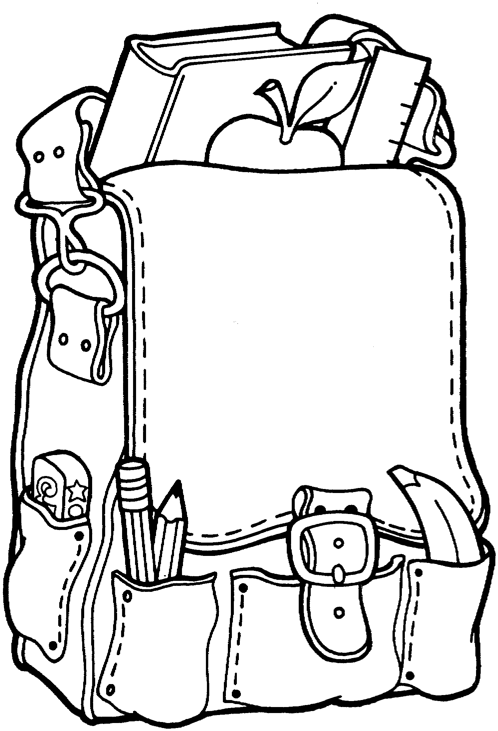

**-** Organize yourself!!! (You’ll need a 3 ring binder or several folders)

- Student Planner

- Thumb drive

- Email account

- Writing Utensils

- Folder for writing portfolio

- Plenty of loose leaf paper

**Attendance:**

There is a direct correlation between regular attendance and student success, particularly in a block schedule. Since classes meet only 2-3 times per week, attendance in each class is essential. If you miss a class, it is your responsibility to meet with me during study block the next day you attend school to receive missed work. If you know you will be absent for a particular class, be proactive and get the work in advance. I am available **EVERYDAY** during study block in roomA-215, or can be reached by phone at 359-5183, ext. 1301, or email at kkuhn@rhnet.com or kristian_kuhn75@yahoo.com.

**Remember:**

You can learn, especially if you are enthusiastic, eager, and continually trying.



It is your obligation to be a responsible student.



Each of us has the right to learn in a safe and comfortable environment.



Be a proactive student – this is your education.



RESPECT yourself, RESPECT your peers, and RESPECT me.



Honesty is important. Please be honest with yourself, your peers, and me. You are expected to achieve success with integrity. Academic dishonesty is a serious violation of scholarship standard, and will not be tolerated.



Active involvement is crucial for your success.



Work hard, ask questions, and have some fun!

