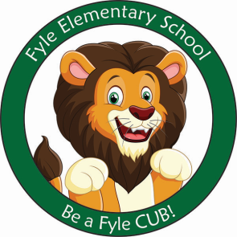

Mrs. Janofsky’s Weekly Update

April 5, 2019

Math

We are continuing to work to understand and solve story problems. We are mixing addition and subtraction problems. Right now we are focusing on listening to the problem and understanding the actions in the story.

We have a daily sprint now that assesses our progress with addition and subtraction facts. Be sure to continue to practice the addition and subtraction cards.

ELA

This week we have been working to read sentences and then draw a picture to match. This is a fun way to show our understanding of what we have read. We have gotten so good at it that we tried a poem about spring! I am amazed at how well the children did!!!! We had fun acting the poem out and talking about multiple meanings of words. In Fundations, we have continued to work with the digraphs. We are using them as part of our sentences too. /Th/ continues to be confusing with the /f/ sound. We will continue to focus on clarifying these sounds. Next week, look for a writing journal to use over break.

Science

We are busy learning about the season of Spring. We have been learning about the changes that happen to both animals and us during this change of season. Next Thursday, we will celebrate Spring.

Important Information

* Specials next week
  + Monday: B
  + Tuesday: C
  + Wednesday: D
  + Thursday: A
  + Friday: No School
* Library on Wednesday. Please help your child remember their book!
* Reading bags come home every Tuesday, Wednesday, AND Thursday. Please be sure to return them completed the next day.

Sight Words

went

Review words: he, she, me, we, be

