1-2 Exponents and Order of Operations

Before we start evaluating expressions, we need to talk about exponents.



Let’s evaluate a few exponents

|  |  |  |
| --- | --- | --- |
| _______________________ | _______________________ | ____________________ |

We can think of many different activities that require us to follow a specific order when completing the task. In order to evaluate expressions we need to follow a specific order for doing operations.

P

E

M

D

A

S

Let’s try a few…

1.  2. 

3. Evaluate  for  and 

4. Evaluate each expression for ,  and .

|  |  |
| --- | --- |
| a) | b) |

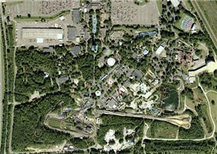5. A neighborhood association turned a vacant lot into a park. The park is shaped like the trapezoid below. Use the formula to find the area of the lot.









Practice 1-2 Name______________________________

**Simplify each expression.**

1. _____________ 2. _____________

3. _____________ 4. _____________

**Evaluate each expression for**  **and** 

5. _____________ 6. _____________

7. The equation represents the sale price *s* of an item with an original price *p*, after a 15% discount. Find the sale price of an item that originally cost $20.