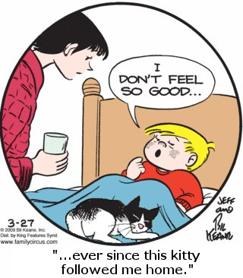

**Directions**:

☺ Choose one vignette to base your analysis on

* “Us & Them”
* “Visiting Hours”
* “Littlest Hitler”
* “Common Scents”

☺ Ground your thesis in a New Critical or Deconstructive concept

☺ Proceed syllogistically

☺ Address the glitches of your last essay and seek to improve

☺ Cover the STD’s (Syntax, Tone, Diction)

☺ Start using the theory (Dichotomy, binary, juxtaposition, irony, paradox, tension, ambiguity, etc).