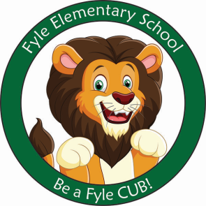

Mrs. Janofsky’s Weekly Update

January 11, 2019

ELA

We were very excited to meet author and illustrator Matthew McElligott. We were very interested in how he made the pictures in his book. After hearing his stories, we were inspired to create and write about an alien of our own. We have some very creative ideas! In Fundations, we are working hard to learn to properly form the upper case letters. We are working to be flexible to understand the upper case letters are also called capital letters. Tapping has become something we are working hard to understand and apply to our reading and writing. In today’s folder, you will find the Fundations newsletter that includes the language to form letters.

Math

The new math vocabulary has been a little tricky this week. We are working to understand the word “fewer.” This word is used for comparing groups. For example, there are fewer markers than children. Please practice this word at home with your child using objects in play or around the house. Have fun with it!

Social Studies/Science

This week we have been discussing winter as it now feels like it! The children will tell you this makes me sad as I don’t like snow. We have read many books about it and also done some writing prompts.

Important Information

* Specials after break:
  + Monday: D
  + Tuesday: A
  + Wednesday: B
  + Thursday: C
  + Friday: D
* Library on Wednesday. Please help your child remember their book!
* No School on January 21, 2019
* No School on January 25, 2019
* Sight word bags are being updated.
* End of Quarter 2 assessments have begun! I am impressed with what the children are showing me they know!

Sight Words

Said play do

Reading bags now come home twice a week! Be sure to return them on Wednesday and Friday! The children are doing an excellent job remembering! Thank you for your support!