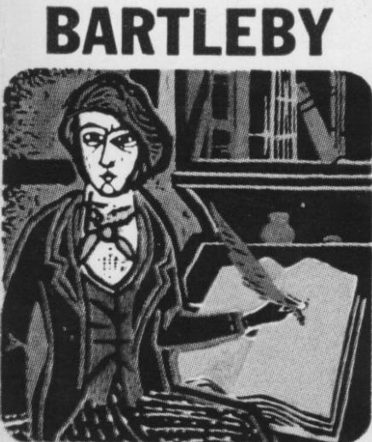

**Essential Questions**

☺How does the subtext of the plot create Bartleby’s worldview?