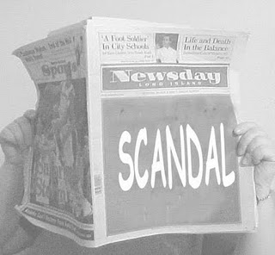

**♦ Cross Analysis Essay**

For this essay of 3 pages in length, you will use *Doubt* as your primary text for analysis and compare it to one of the following texts:

[](http://www.google.com/imgres?imgurl=http://corndogger.com/blog/wp-content/uploads/2009/06/celebrity-twitter-cartoon.jpg&imgrefurl=http://corndogger.com/blog/social-media-fun/celebrity-twitter-overkill-cartoon/&usg=__wa5YB0MJ2SVSRSQKaGsY5COnkXo=&h=282&w=396&sz=328&hl=en&start=27&itbs=1&tbnid=oF_r6mwKfo9YMM:&tbnh=88&tbnw=124&prev=/images%3Fq%3Dcelebrity%2Bcartoon%26start%3D20%26hl%3Den%26sa%3DN%26gbv%3D2%26ndsp%3D20%26tbs%3Disch:1) Choose any high profile celebrity, as well as the principle characters in *Doubt*, and examine how the following essential question operates in both instances – How is it that a stereotype can leave an individual vulnerable to manipulation and deceit? In other words, cross your analysis between the play and a celebrity and examine how they are victimized by their stereotype (examples: Michael Jackson, Britney Spears, Barry Bonds, Tom Cruise, etc.).

[](http://images.google.com/imgres?imgurl=http://newpolcom.rhul.ac.uk/storage/simpsons164.gif-for-web-LARGE.jpg&imgrefurl=http://newpolcom.rhul.ac.uk/npcu-blog/2008/4/23/who-would-the-simpsons-vote-for.html&h=630&w=551&sz=33&hl=en&start=1&usg=__c7JAs23DQ52pTX3Xy9jOaHiwR1A=&tbnid=rgYP151nkWqs3M:&tbnh=137&tbnw=120&prev=/images%3Fq%3DSimpsons%26gbv%3D2%26hl%3Den)Quite recently, several satirical cartoons and late show talk hosts have addressed the church scandal. Choose any one of these depictions and cross your analysis between this particular episode and the play *Doubt.* More importantly, when your cross your analysis between these texts, consider how both pieces of literature operate within any one of our essential questions.

[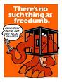](http://www.google.com/imgres?imgurl=http://www.rjdposters.com/Content/Store/404240020-MB244.JPG&imgrefurl=http://www.rjdposters.com/Store/DrawProducts.aspx%3FCategoryID%3D53%26PageID%3D114&usg=__5vvcyHjKUVImyurIwwJMH79fs_U=&h=296&w=225&sz=29&hl=en&start=41&itbs=1&tbnid=MIq7iTmaeSLKuM:&tbnh=116&tbnw=88&prev=/images%3Fq%3Dfreedumb%26start%3D40%26hl%3Den%26sa%3DN%26gbv%3D2%26ndsp%3D20%26tbs%3Disch:1) If you have a great idea for a cross-analysis, throw it my way. Just to toss

out some more ideas – how about comparing *Doubt* to a famous painting? Heck, you

could even compare it to another film. Whatever you decide, I’ll probably be game.

🖉 Clearly establish a position (thesis) in your introductory paragraph

🖉 Print 2 articles from the databases to help you support your argument (**IF YOU”RE CHOOSING THE FIRST PROMPT**)

🖉 1st premises **must** argue something!!

🖉 You need to quote directly from the play and your 2 sources

🖉 Properly cite and quote (Follow my examples)

🖉 Include a Works Cited page

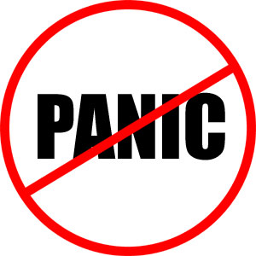 There is absolutely no need to panic!! As with every essay I assign, I will walk you through the process. Heck, I’m actually going to write it with you! Just pay attention and follow my lead. The rest will take care of itself.