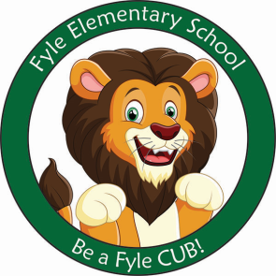

Mrs. Janofsky’s Weekly Update

September 14, 2018

Math

This week we have been working to understand that the amount of objects in a group does not change regardless of how it is oriented. The children are working to understand the difference between a row and a column. We will continue to work with counting within five for the next week. Number formations will also be emphasized and practiced.

ELA

Our first color week has been a lot of fun. We have read books about the colors, sang songs, and create lists of things for each color. We are working to read each of the color words. In writing, we are working to draw details in our pictures. We have used the colors to support us with making details. This week we also have begun working with our first rubric. The coloring rubric helps us to remember to use colors that make sense, color in the lines, and to make sure we have not white space.

Just a reminder that book orders are due September 21st. Orders can be placed on line or by sending in the forms.

Social Studies

This week we discussed that rules can have consequences and rewards. We have read several books about following rules. We continued to practice learning to be a Fyle CUB. The children are doing well learning the classroom rules and being Fyle CUBs.

Important Information

* Next week’s letter schedule:
  + Monday: B
  + Tuesday: C
  + Wednesday: D
  + Thursday: A
  + Friday: B
* Library on Wednesday. Please help your child remember their book!
* Fundraisers are due on Friday.
* Book Orders due Friday
* Ice Cream Social-September 21
* Please be sure to sign and return your child’s yellow Friday letter.

Ways to Reach Me:

Phone: 359-5430

Email: [cjanofsky@rhnet.org](mailto:cjanofsky@rhnet.org)

Note in your child’s daily folder.

