Cumulative Frequency Histograms

Another kind of histogram is the cumulative frequency histogram. This displays the *total frequency* of all data up to and including each interval.

Cumulative Frequency Histogram

Frequency Histogram

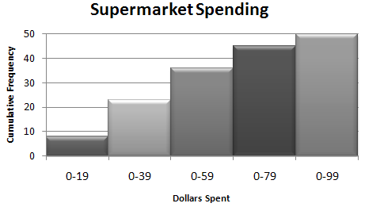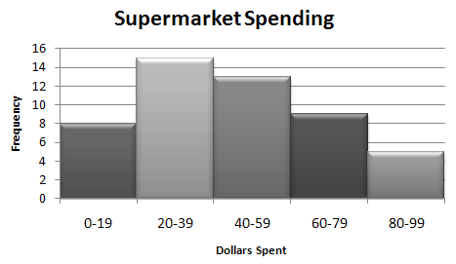

The weight of the cats at the local Humane Society were measured and recorded below.

|  |  |  |  |  |  |  |  |  |  |  |  |  |  |  |  |  |  |  |  |  |  |  |  |  |  |
| --- | --- | --- | --- | --- | --- | --- | --- | --- | --- | --- | --- | --- | --- | --- | --- | --- | --- | --- | --- | --- | --- | --- | --- | --- | --- |
| |  |  | | --- | --- | | Pounds | Frequency | | 0-3 | 3 | | 4-7 | 10 | | 8-11 | 6 | | 12-15 | 2 | | 16-19 | 4 | | |  |  | | --- | --- | | Pounds | Cumulative Frequency | |  |  | |  |  | |  |  | |  |  | |  |  | |

In order to pass a driver’s safety course, a person must answer 45 out of 50 questions correctly. The cumulative histogram below gives the scores of those who passed the test.

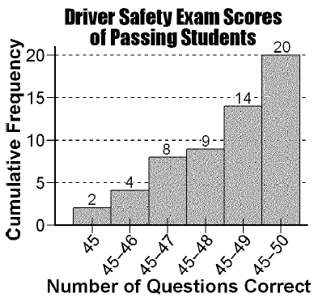

How many total students passed the driver’s safety course? _________________________  
  
How many students answered 49 questions correctly? _________________________  
  
Of the people that passed, how many got 48 questions or less? ­_________________________

Below is a frequency histogram showing the math test scores for a group of students.

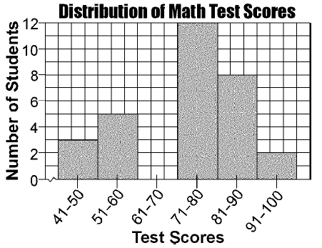

Based on the data above, complete the *cumulative* frequency table and construct the cumulative frequency histogram.

|  |  |
| --- | --- |
| Test Score Intervals | Cumulative Frequency |
|  |  |
|  |  |
|  |  |
|  |  |
|  |  |
|  |  |

Practice: Cumulative Frequency Histograms Name______________________________

1. The Fahrenheit temperature readings on 30 April mornings in Stormville, New York, are shown below.

41°, 58°, 61°, 54°, 49°, 46°, 52°, 58°, 67°, 43°,

47°, 60°, 52°, 58°, 48°, 44°, 59°, 66°, 62°, 55°,

44°, 49°, 62°, 61°, 59°, 54°, 57°, 58°, 63°, 60°

Using the data, complete the frequency table below.

|  |  |  |
| --- | --- | --- |
| Interval | Tally | Frequency |
| 41-45 |  |  |
| 46-50 |  |  |
| 51-55 |  |  |
| 56-60 |  |  |
| 61-65 |  |  |
| 66-70 |  |  |

Complete the **cumulative** frequency table.

|  |  |
| --- | --- |
| Interval | Cumulative Frequency |
| 41-45 |  |
| 41-50 |  |
| 41-55 |  |
| 41-60 |  |
| 41-65 |  |
| 41-70 |  |

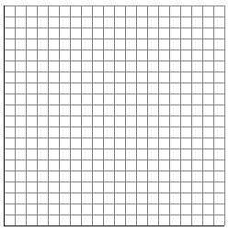

2. People in the shopping mall were stopped and asked how many televisions they have in their home. The data was recorded in the ***cumulative frequency histogram***below.

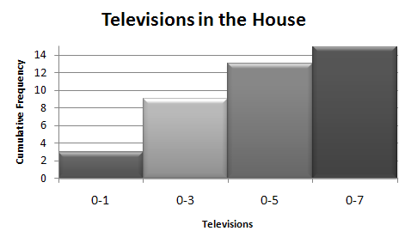

How many total people were surveyed at the mall? _________________________

How many people had more than 4 televisions in their home? _________________________

How many people had between 6-7 televisions? _________________________

In which interval did the most people answer? (Multiple Choice)

|  |  |  |  |
| --- | --- | --- | --- |
| a. 0-1 | b. 2-3 | c. 4-5 | d. 6-7 |