**Reference Table Review**

**Regents Chemistry**

**Name:**

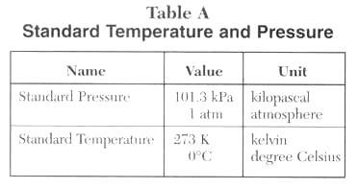

**Table A Questions:**

1. Convert 2 atm in kPa. **202.6 kPa**
2. Convert 303.9 kPa in atm. **3 atm**
3. What is the difference between 1 K and 1oC? **273 degrees, Celsius is higher**
4. What is the 0 K temperature called? **Absolute zero, no kinetic energy**
5. Describe the volume and the movement of the particles in a sample of H2 gas at -273oC. **no volume, no movement (-273**o**C = 0 K)**
6. What does STP stand for? **Standard temperature and pressure**
7. What are the two units of pressure represented in the table? **kPa & atm**
8. What are the two units of temperature represented in the table? **Kelvin [K] and Celsius**
9. How many pascals are in 10 kPa? **10,000 Pa**

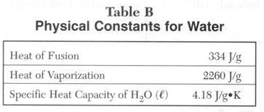

**Table B Questions:**

1. What is the definition of the Heat of Fusion? **Amount of energy needed to melt 1 g of ice**
2. Based on the definition of the Heat of Fusion make up a problem. **How much energy is needed to melt 30g of ice if its temperature is 0 C?**
3. Convert the units of the Heat of Fusion into cal/g  and kcal/g (1 cal = 4.18 J) **80 cal/g, 0.080 kcal/g**
4. Give a synonym for the word fusion. **melting**
5. What is the definition of the Heat of Vaporization? **Amount of energy needed to vaporize 1g of water**
6. Based on the definition of the Heat of Vaporization make up a problem. **How much energy is needed to melt 30 g of ice if its temperature is 100 C?**
7. Convert the units of the Heat of Vaporization into cal/g  and kcal/g (1 cal = 4.18 J) **541 cal/g, 0.540 kcal/g**
8. What is the definition for the Specific Heat Capacity of H2O (l).  **The amount of energy needed to raise 1g of water 1 K.**
9. Based on the definition of the Specific Heat Capacity of H2O (l) make up a problem. **How much energy is needed to raise 30 g of water from 293 K to 358 K?**
10. Convert the units of the Specific Heat Capacity of H2O (l) into cal/g and kcal/g (1 cal = 4.18 J). **1 cal/g, .001 kcal/g**
11. Relate the heat of fusion with energy and bonding. **The heat of fusion is the amount of energy needed to overcome the intermolecular forces between molecules of the solid**
12. Relate the heat of vaporization with energy and bonding. **The heat of vaporization is the amount of energy needed to overcome the intermolecular forces between molecules of the liquid.**

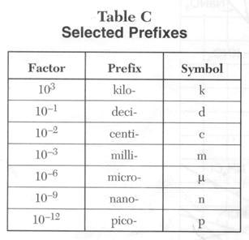

**Table C Questions**

1. What is a prefix? **Comes before a unit to give it a multiple of 10 higher or lower**
2. How many grams are in 10 kg? **10,000**
3. How many meters are in 100 micrometers? **.0001 m**
4. Convert 45 pm to cm. **(0. 000 000 004 5 cm)**
5. Convert 1 kg  to pg. **(1,000,000,000,000,000)**
6. How many decimeters **(10)**, centimeters **(100)**, millimeters **(1000)**, micrometers **(1,000,000)**, nanometers **(1,000,000,000)**, and picometers **(1,000,000,000,000)** are in 1 meter?
7. What is the name of this unit system and what is it based on? **(System International ([also called metric]) powers of 10.**

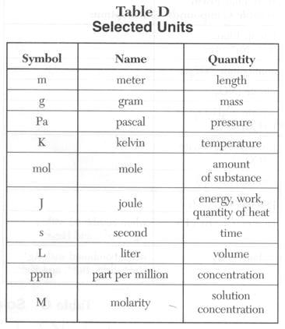

**Table D Questions:**

1. What are units? **What we use to measure quantities such as length, mass, and volume**
2. What units could be used to calculate the density of a solid? **mass and volume**
3. What are the units for molarity? **Moles per (divided by) liters**
4. What units could be used to measure the velocity of a molecule of gas? **Meters per second**
5. What is the numerical value of a mole? **6.02X 10^23 atoms or molecules**
6. A calorimeter is used to measure the amount of heat released in chemical reactions, what units are used? **Joules (J)**
7. The concentration of pollutants can be measured in ppm. Write the fraction that ppm represents? **(parts per million, 1 mg / 1 L of solution)**
8. What are the units quantities used in STP? **101.3 kPa, 273 K (1 atm, 0 C)**

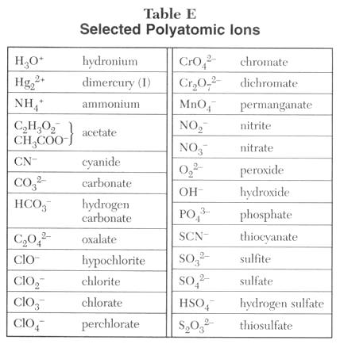

**Table E Questions:**

1. What is a polyatomic ions? **An ion made of more than one atom covalently bonded together**
2. What is the charge of carbonate? **2-**
3. What is the charge of permanganate? **1-**
4. Why does acetate has two different ways of writing it? **It is organic so it has a condensed and a molecular formula**
5. What does the Roman numeral “I” on dimercury (I) stand for? **The roman numeral stands for the +1 charge on each atom of mercury. The two mercury atoms together give a total charge of +2**

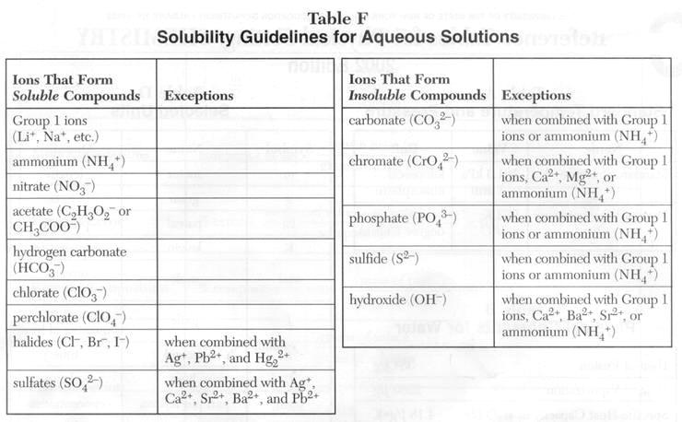

**Table F Questions**

Write the products and balance the reaction for the following double replacement reactions including the phase to describe the solubility of the products.

1. MgSO4 (aq) +  BaCl2 (aq) --> **MgCl2 (aq) +  BaSO4(s)**
2. Ca(OH)2 (aq) + H2SO4 (aq) -->**2H20 (l)+  CaSO4(s)**
3. Al2(SO4)3 (aq) + ZnCl2 (aq) --> **AlCl3 (s)  + Zn(SO4) (aq)**
4. 2Ag(NO3) (aq) + MgCl2 (aq) --> **2AgCl (s) + Mg(NO3)2 (aq)**
5. AlBr3 (aq) + K2SO4 (aq) --> **no rxn**
6. FeCl3 (aq) + NaOH (aq) --> **NaCl (aq)+ Fe(OH) 3 (s)**
7. AgNO3 (aq) + NaCl (aq) --> **AgCl (s) + NaNO3 (aq)**



**Table G Questions:**

1. What compounds show a decrease in solubility from 0 to 50oC? **SO2, NH3, HCl (all the gases)**
2. Which salt is most soluble at 60oC? **probably KI**
3. Which compound is least soluble at 100oC? **SO2**
4. Which salt is least soluble at 70oC? **KClO3**
5. How many grams of KCl can be dissolved in 500 g of H2O at 30oC? **5 x (35) = 175 g**
6. At 50oC, how much KNO3 can be dissolved in 200 g of H2O? **2 x (85g) = 170g**
7. Which salt shows the least change in solubility from 50 to 100oC? **NaCl**
8. At 30oC, 90 g of NaNO3 is dissolved in 200 g of H2O. Is the solution saturated or unsaturated? **unsaturated**
9. A saturated solution of KClO3 is formed from 50g of water. If the solution is cooled from 90oC to 70oC, how many grams of precipitate are formed? **2g**

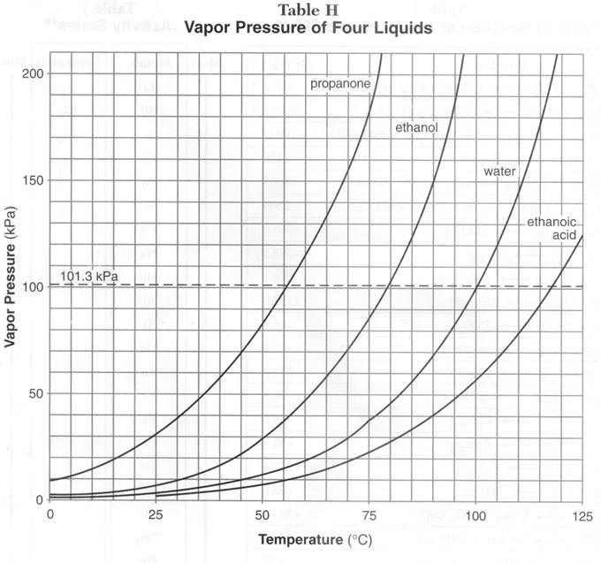

**Table H Questions:**

1. Define the term vapor pressure. **The pressure exerted by molecules that have evaporated from a liquid in a sealed container. Depends only on temperature of the liquid (not surface area of liquid, or volume of liquid).**
2. What is the vapor pressure in kPa and atm of water at 100oC? **1 atm, 101.3 kPa**
3. What is the vapor pressure in kPa and atm of ethanoic acid at 120oC? **108 kPa, [108/101] x 1 atm = 1.07 atm**
4. What is the vapor pressure in kPa and atm of propan**one** at 75oC? **181 kPa, 181/101 x 1atm = 1.79 atm**
5. Compare the vapor pressure of the four liquids at 70oC**. Greatest=propanone; least=eth. acid**
6. Liquids boil when the vapor pressure is equal to the pressure on the system. For instance, water boils at 100oC at 1atm but when the pressure is 2 atm water boils at 118oC. Consider the four liquids boiling at 70oC, what is the pressure on the system for each liquid?

**If the liquids are boiling at 70 degrees then atm press must be, for each:**

**Propanone - atm press = 155 kPa; ethanol – atm press=70 kPa; watet – atm press=30kPa; ethanoic acid – atm press=19 kPa**

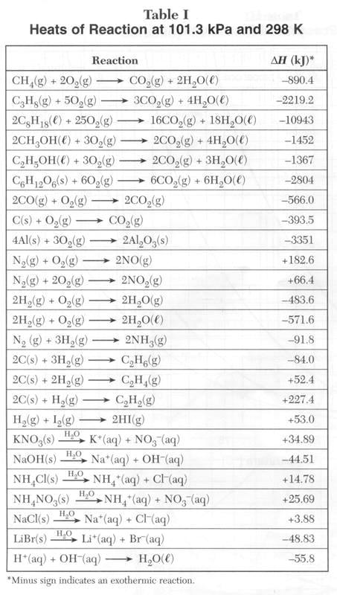

**Table I Questions:**

1. Draw a potential energy diagram for each reaction. **Yeah right… exo products are lower**
2. What is the formula for Heat of reaction (ΔH)? **H = products energy – reactant energy**
3. What is the sign of ΔH when the Heat of reactants is more than the Heat of the products? **negative**
4. What is a exothermic reaction? **One that has less energy in the products, heat EXITS to the surroundings.**
5. What is the sign of ΔH when the Heat of reactants is less than the Heat of the products? **Could it be … positive**
6. What is an endothermic reaction? **More** **energy in products than reactants, heat must ENTER from surroundings to happen**
7. What is the pressure and temperature at which ΔH was calculated for the reactions in the table? **See top of the Table I!**

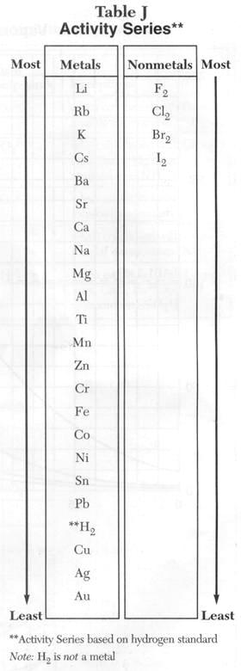

**Table J Questions:**

1. Is a more active metal easier to oxidize or reduce? **Ox … “metalliness” is due to losing e- (LEO)**
2. Is a more active nonmetal easier to oxidize or reduce? **Red… nonmetals gain e- (GER)**
3. A solution of CrCl2 will react with which of the following metals?

Ag **Al** Cu Mg Ni **Zn**

**Metal higher than Cr+2**

1. Write the oxidation and reduction half-reactions (if they occur) for
   1. A copper penny placed in a silver nitrate solution. **Cu + 2 Ag + 🡪 Cu+2 + 2 Ag**
   2. A zinc bar is placed in a solution of NiCl2

**Zn + Ni+2 🡪 Ni + Zn+2**

* 1. An aluminum nail is placed in a solution of MgCl2 **no rxn**

1. Draw a voltaic cell with a copper electrode and a nickel electrode. Include ions in solution. Label the anode and the cathode. Don’t forget the salt bridge! Show the direction of current flow. Write equations for the oxidation and reduction half-reactions.

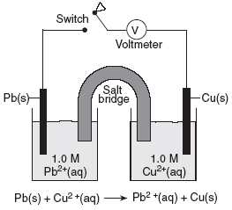**just change Pb for Ni and its all good**

1. Which one of the following pairs represents a spontaneous reaction?

a. Ni, Zn2+ **No** b. Ag+, Cu **Yes** c. Al, Mg2+ **No**

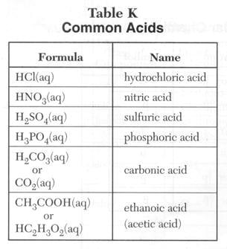

**Table K Questions:**

1. What are Arrhenius acids? **Substances that dissolve in water to form H+ ions (hydronium)**
2. Write the dissociation reaction for each acid in the table. Example: HCl(aq) -->  H+(aq) +  Cl- (aq)

**Example: HCl 🡪 H+ + Cl-**

1. Are acids electrolytes? Why? **Yes, produce ions when dissolved**
2. What is the alternate theory for acids? **Acids donate Protons (H+)** Given this reaction: H2SO4(aq) + H2O(l) <--> HSO4-(aq) + H3O+(aq) find the acids in the forward and reverse reaction. **H2SO4(aq) – forward; HSO4-(aq) - reverse**
3. What are the possible pH for acidic solutions? **1 - 6**

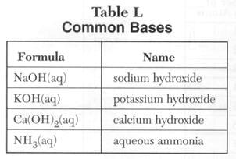

**Table L Questions:**

1. What are Arrhenius bases? **Produce OH- when dissolved in water**
2. Write the dissociation reaction for each base in the table. Example: NaOH(aq) --> Na+(aq) + OH-
3. Are bases electrolytes? Why? **produce ions when dissolved**
4. What is the alternate theory for bases?  **bases bond to H+ (protons)**
5. Given this reaction: CH3COO-(aq) + H2O(l) <--> CH3COOH(aq) + OH-(aq) find the bases in the forward and reverse reaction. **H2O(l) – forward; OH- reverse**
6. What are the possible pH for acidic solutions? **8 – 14**
7. In the process of neutralization, an Arrhenius acid and an Arrhenius base react to form a salt and water. Write 5 neutralization reactions. **KOH + HNO3 🡪 KNO3 + H2O**

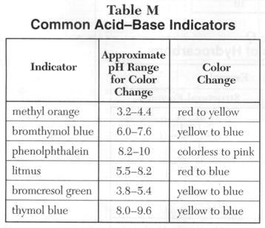

**Table M Questions:**

Describe the color of the indicators in the solutions given below.

**How about you ask how to use this Table M if you are not sure /don’t remember, instead of filling in that stupid chart we put in here!!!**

**Table N Questions:**

1. What is the half-life of neon-19? **17.2 sec**
2. What is the decay mode of plutonium-239? **alpha**
3. Which radioisotope decays the fastest? **Ca-37**
4. Which radioisotope decays the slowest? **Th-232**
5. How many decay modes are included in the table? **3**
6. Write the nuclear reaction of each radioisotope. **Yeah right, just make sure you know how to use this chart,Table O and the Periodic Table to write natural transmutation equations**
7. List all the radioisotopes that undergo beta decay and compare their atomic mass with the relative atomic mass of the respective element. What do you notice and can you find an explanation for the trend? **No thanx**
8. List all the radioisotopes that undergo positron decay and compare their atomic mass with the relative atomic mass of the respective element. What do you notice and can you find an explanation for the trend? **Not today**
9. Alpha decay occurs mainly in isotopes with atomic numbers larger than 60. List all the radioisotopes undergoing alpha decay and verify the statement.   **Ok, this is a dumb question.**

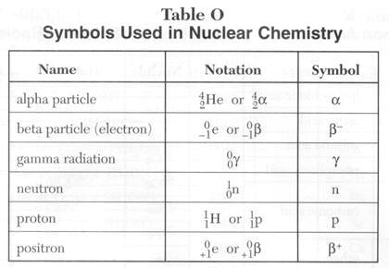

**Table O Questions:**

1. What is the charge and mass of an alpha particle? **Mass = 4 amu charge = +2**
2. What is the difference between a beta particle and a positron? **Beta charge is -1, other is +1**
3. What is the result of adding a positron and a beta particle together? **annihilation**
4. Why is a proton the same as hydrogen-1? **A hydrogen-1 nucleus contains just a proton**
5. What is the charge and mass of gamma radiation? **Zero for both**
6. What is another term for an electron? **Beta particle**
7. Which particle has the most matter? **alpha**
8. What is the symbol for beta particles? **Look in the table above**
9. Which particles will be deflected towards the positive electrode in an electrical field? **beta**
10. Which particles will be deflected towards the negative electrode in an electrical field? **Alpha, and positron**
11. Which particles will not be deflected in an electrical field? **gamma**

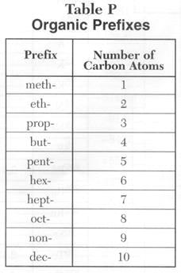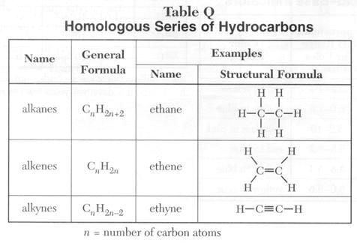

**Table P and Q Question:**

Write the name, molecular formula, and draw the structural formula for five alkanes, alkenes, and alkynes using the table P.

**Remember that molecular formulas are like “C3H8”, whereas structural ones are drawings like shown in the right column of Table Q.**

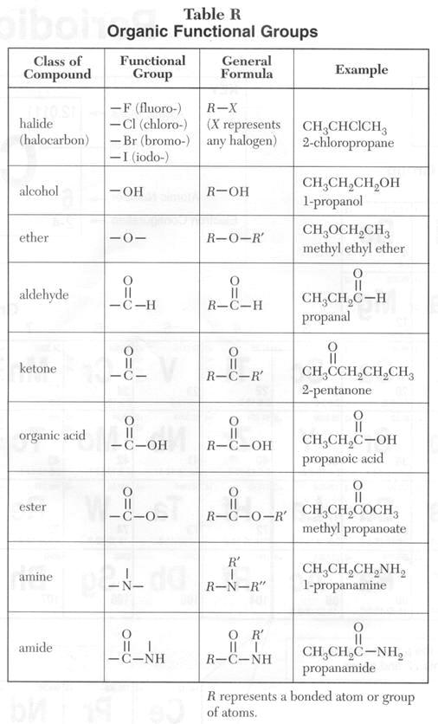

**Table R Question:**

Make up 2 more examples for each class of compounds. Write their names, and draw their structural formulas.

**Show your teacher if you do not know how or are not sure if your are doing this right!**

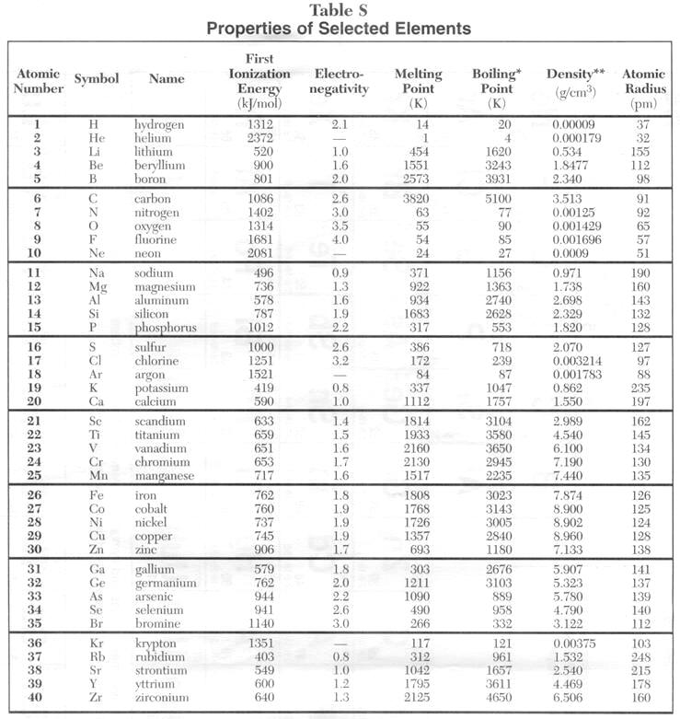

**USE YOUR OWN TABLES: THESE ARE TOO SMALL TO READ!**

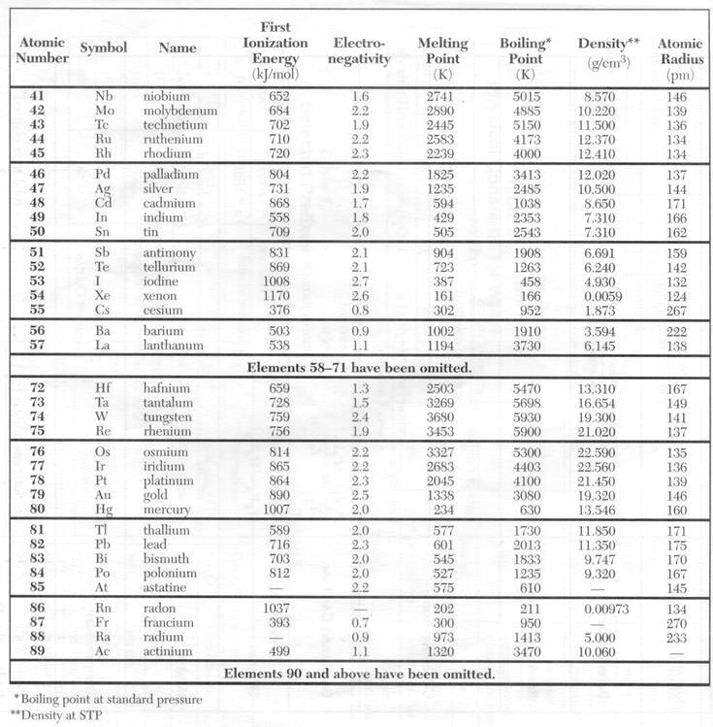

**Table S Questions:**

1. Draw an empty periodic table (omit groups 3-12) and include Symbols, Atomic Number, and Electronegativity value for each element.
   1. Draw a bar graph representing the trend of electronegativity in group 1 and 2. Organize symbols of elements on the X axis and the numerical values on the Y axis.
   2. Draw a line graph representing the trend of electronegativity in period 3 and 4. Organize symbols of elements on the X axis and the numerical values on the Y axis.
   3. In complete sentences, describe the Electronegativity’s general trend in groups and periods.
   4. State the reasons for your observations?
2. Draw an empty periodic table (omit groups 3-12) and include Symbols, Atomic Number, and Ionization Energy value for each element.
   1. Draw a bar graph representing the trend of Ionization Energy in groups 1 and 2. Organize symbols of elements on the X axis and the numerical values on the Y axis.
   2. Draw a line graph representing the trend of Ionization Energy in period 3 and 4. Organize symbols of elements on the X axis and the numerical values on the Y axis.
   3. In complete sentences, describe the Ionization Energy ’s general trend in groups and periods.
   4. State the reasons for your observations?
3. Draw an empty periodic table (omit groups 3-12) and include Symbols, Atomic Number, and Atomic Radius value for each element.
   1. Draw a bar graph representing the trend of Atomic Radius in group 1 and 2. Organize symbols of elements on the X axis and the Atomic Radius on the Y axis.
   2. Draw a line graph representing the trend of Atomic Radius in period 3 and 4. Organize symbols of elements on the X axis and the Atomic Radius on the Y axis.
   3. In complete sentences, describe the Atomic Radius ’s general trend in groups and periods.
   4. State the reasons for your observations?

# Using answers from problems #1 & 2 find any correlation between Electronegativity and Ionization Energy.

1. Using answers from problem #3 find any correlation between Atomic Radius and Atomic Number.
2. Make a bar graph for the boiling points values of the Noble Gases.
   1. Find the correlation between the trend for Atomic Radius and the Atomic Number for the Noble Gases.
   2. Explain your findings.

**IF YOU DID #1-6, You are a SICK-O!!! An actual CHEM NERD!!**

1. At what pressure the Boiling Points have been calculated? **Atmospheric , 1 atm , 101.3 kPa**
2. At what temperature and pressure the Densities have been calculated? **STP**
3. What is the density of 2 moles of water? **1.0 g/mL**
4. Using the density of helium, **0.0000179 g/mL** what is the mass of 2 moles of helium? **8 g**
5. Would the density of neon be higher or lower if its density were calculated at 2 atm.**Higher**
6. What is the general correlation between Melting Points and Boiling Points? **Direct correlation… if an element has a low m. pt. it also has a low b. pt.**

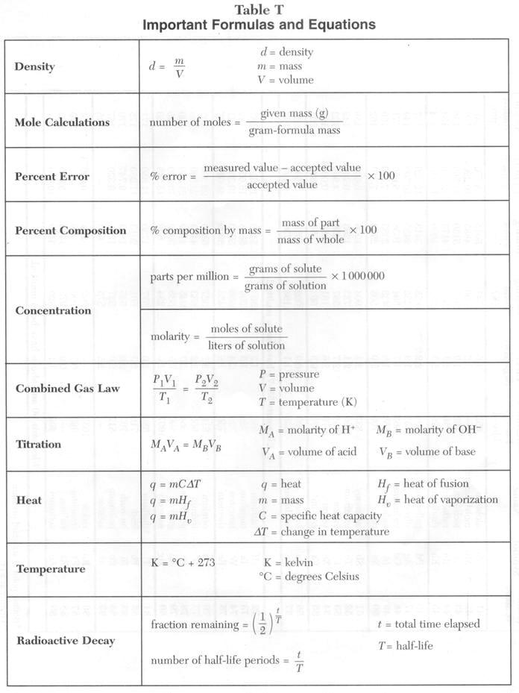

**Table T Questions:**

# Density

1. Calculate m in **terms** of d and v. **m = d x v**
2. Calculate v in terms of m and d. **v = m/d**
3. What is the d of an object with a mass of 102.0 g and a volume of 10 cm3?**102/10 = 10.2 g/mL**
4. What happened to the d of an object whose v decreases? **Nothing d is still the same**
5. A nail (m = 2 g and V = 0.5 cm3) is cut in 2 pieces. Explain why the d of each half remains the same as the original nail. **D is a property unrelated to size**
6. An object has a mass of 23 g and a density of 10 g/cm3 what is its volume? **2.3 mL (2.3 cm3)**
7. What is the density of aluminum? **2.608 g/ml at STP (Table S)**

**Mole Calculations**

1. What is the number of mole in a sample of 45g of H2O? **molar mass = 18, so 45/18 = 2.5 moles**
2. What is the number of mole in a sample of 6g of NH3? **Molar mass = 17, so 6/17 = 0.35 moles**
3. What is the mass of 2 moles of H2O2? **Molar mass = 34, so 34 x 2 = 68 grams**
4. What is the mass of 4 moles of C2H2? **Molar mass = 26, so 26 x 4 = 104 grams**

**Percent Error**

1. Can the Percent Error be less than 0? **Technically yes, means measured value is less than accepted one**
2. What is the difference between the measured value and the accepted value if the Percent Error is 100? **1:2 ratio between the two (one is twice in value of the other)**
3. A Student calculates the density of iron at STP to be 8.956 g/cm3. What is the Percent Error? **7.874 is accepted value (Table S) so 13.7%**
4. Why do we have to calculate the Percent Error in scientific experiments? **TO check the quality of the data**
5. In an experiment a student calculates the atomic radius for iridium. The % error of the calculation is 23 %. What is the experimental value? **Don’t worry about this one**

**Percent Composition**

1. What is the percent composition by mass of H in H2O2? **2/34 x 100 = 5.9%**
2. What is the percent composition by mass of all the elements in (NH4)3PO4? **Solve molar mass and then divide mass from each element by the molar mass. N = 28.1%, H = 8.1%, P = 20.8%, O = 43.0%**
3. What is the percent, by mass, of water in MgSO4.2H2O? **Find molar mass of MgSO4 and add to it the mass of 2x molar mass of water = 120.3 + 2(18) = 156.3 is total mass of the hydrate. 36/156.3 = .23 or 23% of the mass is from water**
4. How many grams of O can be produced from the decomposition of 50g of H2O? **Not to worry**
5. How much phosphorus can be recovered from 25g of (NH4)3PO4?
6. How much potassium can be produced from 125g of KMnO4?

**Concentration**

1. Describe the laboratory procedure to make a 2 M NaCl(aq) solution.
2. What is the molarity of a solution of KOH if 1000 ml of the solution contains 11.2 grams of KOH? **11.2 g KOH is 0.2 moles of KOH (11.2/molar mass = 11.2/ 56) Molarity = 0.2/1.0 L = 0.2**
3. How many moles of KOH are contained in 250 mL of 2.0 M solution of KOH? **2 M x .250 L = 0.5 moles**
4. A 40.0 milliliter sample of 0.50 M HCl is diluted with water to a volume of 100. milliliters. What is the new concentration of the solution? **Don’t worry about this one.**
5. What is the concentration in parts per millions if a 500 g solution of copper (II) sulfate contains 5 mg of copper (II) sulfate?

**Combined Gas Law**

1. Given the formula for the combine gas law, express every single term in term of the other terms.
2. What will be the new formula if temperature is constant? **P1V1 = P2V2**
   1. What is the name of this formula? **Boyles Law**
   2. Draw a line graph representing the relationship. 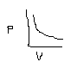
   3. Explain in a sentence the result of the line graph. **As P increases on a gas, its volume decreases… INVERSE relationship.**
   4. Find an example to illustrate your findings. **Gas contained in a syringe.**
3. What will be the formula if pressure is constant? **V1/T1 = V2/T2**
   1. What is the name of this formula? **Charles Law**
   2. Draw a line graph representing the relationship. 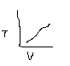
   3. Explain in a sentence the result of the line graph. **As T increases, so does V, DIRECT Relation.**
   4. Find an example to illustrate your findings. **Hot air balloon**
4. What temperature scale has to be used for temperature? **KELVIN!!!!**
5. Do any specific scales have to be used for pressure and volume? **no**
6. At STP, a sample of hydrogen gas has a volume of 10 L. If the temperature is double and the pressure is double, what is the new volume of the gas sample? **10 L (double the T causes doubling of V, but doubling pressure causes volume to reduce to ½, so no volume change)**
7. At STP, a sample of helium gas has a volume of 5 L. If the temperature is quadruple and the pressure is triple, what is the new volume of the gas sample? **4x T causes 4x volume, but 3x P causes 1/3 x volum,e, so volume changes by 4 x 1/3 or 4/3. So 4/3 x 5 = 20/3 = 6.67 L**

**Titration**

1. What is a titration? **Controlled neutralization of an acid of known concentration against a base of unknown concentration (or visa-versa), for the purpose of figuring out the concentration of the acid or the base … Use MaVa = MbVb**
2. How many milliliters of 0.50 M NaOH are required to exactly neutralize 20.0 milliliters of 0.20 M HCl? **(0.20 M)(20 mL) = (0.50 M) Vb Vb = 8 mL**
3. If 100. milliliters of a 3.0 M solution of HCl is exactly neutralized by 80. milliliters of NaOH, what is the molarity of the NaOH solution? **3.75 M NaOH**
4. What is the molarity of an HNO3 solution if 10.0 milliliters of 0.40 M LiOH is required to exactly neutralize 200 milliliters of the HNO3 solution? **0.020 M**
5. How many milliliters of 1.0 M HCl are needed to exactly neutralize 50. milliliters of 0.5 M KOH? **25 mL**
6. Describe the laboratory procedure of titration. **Measure a known amount of the solution of unknown concentration (say it s the acid). Add an indicator (usually phenolphthalein or bromothymol blue). Slowly add the other solution (say the base) until the indicator changes to its “neutral” color. Measure the amount of base added. Calculate the concentration of the acid using MaVa = MbVb equation.**

**Heat**

1. What is the definition of specific heat capacity? **Heat energy in Joules needed to change the temperature of one gram of the substance by one degree C or K.**
2. How is the heat of fusion defined? **Heat energy needed to MELT one gram of the substance**
3. What is the definition of heat of vaporization? **Heat energy needed to BOIL one gram of the substance**
4. Write the formula for change in temperature. **T**
5. What is the specific heat capacity of water? **Look on Table B**
6. The temperature of 10 g of water has increased by 10 K, how much heat was absorbed?

**Use q = mc T = (10 g) (4.18 J/g oC) (10oC) …. (change of 10 degrees K = change of 10 degrees C as well)**

1. After an experiment using 2 g of water, 20 J was released in the surrounding and the final temperature is 257 K, what was the original temperature of the water? **Don’t do**
2. What is the value for the heat of fusion for water in J/g?**Table B…**
3. What is the value for the heat of vaporization in J/g? **Table B…**
4. How many Joules are required to melt 1000 g of water? **q = mHf = 1000 g x 334 J/g = 334,000 J or 334 kJ**
5. How many Joules are needed to vaporize 10 g of water? **q = mHv = 10g x 2260 J/g = 22,600 J = 22.6 kJ**

**Temperature**

1. Convert the followings: 0oC to K, **273 K** 373 K to oC, **100oC** 35oC to K **308 K**
2. What is the difference in degree Celsius and in Kelvin between the freezing and the boiling point of water? **100 degrees on both scales**
3. How is temperature defined? **Measure of average kinetic energy of the particles in the sample**
4. Is 1 K equal to 1oC? Why? **well… a CHANGE of 1 degree on the Celsius scale is equal to a CHANGE of 1 degree on the Kelvin scale. However, the temperature 1 K is -272 oC**

**Radioactive Decay**

1. What is the concept of half-life? **Amount of time it takes for ½ of the atoms in a sample of a radioactive element to transmutate (radioactively decay by emitting radiation).**
2. What is the concept of Radioactive Decay? **Elements that have naturally unstable nuclei will emit a form of radiation (they will “decay”) as the ratio of protons: neutrons is adjusted to achieve more stability.**
3. What is the value of (1/2)0 ? **1**
4. What is the value of (1/2)1 ?
5. When is t/T = 0?
6. When is t/T = 1?
7. After how many half-life periods an original sample of a radioisotope will decreased by ¼? **2**
8. What is the fraction remaining after 5 half-lives have elapsed? **1/32**
9. What is the half-life of nitrogen-16? **7.2 sec**
10. A sample of uranium-238 is stored in a safe place, what is the amount remaining after 1.35 x 1010 years and what kind of decay particle are given throughout the years? **This is 3 half lives (divide 1.35 E^10 by i/2 life of U-238) so 1/8 remains. Table N says this to happen by alpha decay.**
11. A sample of an unknown radioisotope has taken 2 weeks and 2/5 of a day to have 1/64 of the original sample remaining. What is this radioisotope? **Don’t do**
12. If the initial mass of a sample of cesium-137 is 1.00 g, how much will remain after 151 years? **151 years divided by half-life of 30 years is 5 half lives, so 1/32 of 1.00 g remains, or 0.03125 g**
13. Consider a sample of fossilized wood that originally contained 24 g of carbon-14. It now contains 1.5 g of carbon-14. **24 🡪 12g 🡪 6 g 🡪 3g 🡪 1.5 g**, **so 4 half lives of time have elapsed** How old is the sample? **C-14 half life is 5730 yrs, so 5 x 5730 y = 28,650 years**
14. A 64 g sample of germanium-66 is left undisturbed for 12.5 hours. At the end of that period, only 2.0 g remain. What is the half-life of this material? **64g 🡪 32g 🡪 16g 🡪 8g 🡪 4g 🡪 2g so 5 half lives have occurred, so 12.5 divided by 5 = 2.5 hours is the value of one half-life.**
15. If a pellet of cobalt-60 that has been in storage for 26.5 years contains 14.5 g of cobalt-60, how much of this radioisotope was present when the pellet was put into storage? **26.5 y divided by the half life of 5.26 y = about 5 half lives. So if 14.5 g remains now, work by doubling back 5 times… 14.5g 🡪 29g 🡪 58g 🡪 116g 🡪 232g 🡪 464 g**
16. How long will it take for 1.00 gram of strontium-90 to decay to 125 mg? **125 mg = 0.125 g… 1 🡪 0.5g 🡪 0.25g 🡪 0.125 g so 3 half-lives have elapses. Half life is 28.1 y so 3 x 28.1 y = 84.3 y**
17. A patient receives iodine-131 as a medical treatment on Sunday October 18 at 8:00:00 am.   
    On what day, date, hour, minute, and second will only 1/8 of the original sample still be radioactive? **fogedabowdit**

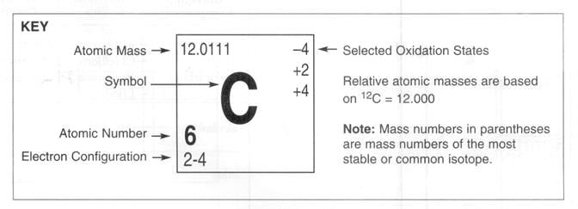

**Periodic Table Questions:**

1. Which elements are in the liquid phase at room temperature?**bromine (Br) and mercury (Hg)**
2. Which elements are in the gas phase at room temperature? **All 6 noble gases as well as O, N, F, Cl H**
3. What are the 2 main divisions of the periodic table? **Metals and nonmetals**
4. What are the 7 metalloids?**B, Si, Ge, As, Sb Te, Po**
5. What is the number of e-, p, and n in a neutral atom of nitrogen? **Can’t say #n without knowing the isotope number. But has 7 p and e**
6. What is the Atomic Mass of xenon? **131.29**
7. What is the Atomic Number of barium? **56**
8. What is the electron configuration of iodine? **2-8-18-18-7**
9. What are the relative atomic masses based on? **Mass and % abundance of the naturally occurring isotopes of that element (know how to set up that calculation)**
10. What are the Selected Oxidation States of chlorine?**-1, +1, +3, +5, +7**
11. What is the Symbol of krypton?**Kr**
12. Name the 6 Noble Gases?**in order helium neon argon krypton xenon radon**
13. What are the characteristics of metals?**shiny (luster) conductors malleable**
14. What are the characteristics of nonmetals?**dull non-conductors brittle**
15. What are the characteristics of metalloids?**some of both metals and nonmetals**
16. Is hydrogen considered a metal?**NO!!!!!!!!!!!!!!!!!!!!!!!!**
17. What is the difference between helium and the other Noble Gases?**He has only 2 valence e, others have 8**
18. How many groups are in the Periodic Table of Elements?**18**
19. How many periods are in the Periodic Table of Elements?**7**
20. What does the period number indicate in the electron configuration of an atom? **Number of energy levels of electrons that element uses**
21. What does the group number indicate in the electron configuration of an atom?**Number of valence e that element has**
22. What is the name of groups 3-12? **Not to worry about it**
23. What is the name of group 1?**alkali metals**
24. What is the name of group 2?**alkaline earth metals**
25. What is the name of group 17?**halogens**
26. What is the name of group 18?**noble gases**
27. What does the Selected Oxidation States numbers represent?**possible charges that element is known to take on in its various compounds it forms with other elements**
28. How many valence electrons are in an atom of cesium? **Cs… one**
29. What is the outermost principal quantum number for an atom of arsenic? **As – the 4th energy level**
30. What element has an electron configuration of 2-8-10-2? **Find it in order on the chart or count up 2+8+10+2 = 22 e so element #22 so Ti**