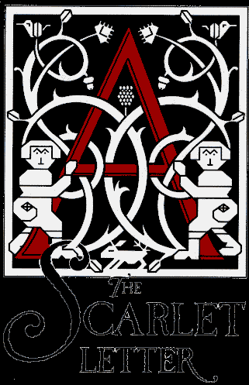

**Prompt**

* Choose one of the essential questions below and write an argumentative essay that directly answers your selected question. You must use the text to support your answer – in other words, you’ll need to quote directly from the text. Your essay needs to be at minimum two pages in length.
* What is the sin of hypocrisy?
* Who and what defines a person?
* When is it that crime is a virtue?
* To what extent does alienation lead to self-discovery?
* When is it that darkness takes the shape of purity – light, evil?