Name: _________________________________________

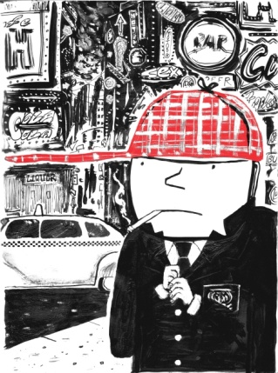

☺ Explain 5 of the following symbols and how each connects thematically to the novel

🖉 Ducks 🖉 The Catcher in the Rye 🖉Museum of Natural History 🖉Allie’s Mitt

🖉 Jane’s kings in the back row 🖉 Carousel 🖉 the sun 🖉 red hunting hat

_________________________________________________________________________________________________

________________________________________________________________________________________________

_________________________________________________________________________________________________

_________________________________________________________________________________________________

________________________________________________________________________________________________

_________________________________________________________________________________________________

_________________________________________________________________________________________________

________________________________________________________________________________________________

_________________________________________________________________________________________________

_________________________________________________________________________________________________

________________________________________________________________________________________________

_________________________________________________________________________________________________

|  |
| --- |
| ☺ Directions: For each of the following quotes, identify who said it, to whom, the situation in the novel, and why it is significant. Record your answers on this handout. |
| 1) "*Life is a game, boy. Life is a game that one plays according to the rules.*"  2) "*Ask her if she still keeps all her kings in the back row.”*  3) "*For Chrissake, Holden. This is about a goddam baseball glove.*"  4) " It was that kind of a crazy afternoon, terrifically cold, and no sun out or anything, and you felt like you were disappearing every time you crossed a road.”  5) "*The mark of the immature man is that he wants to die nobly for a cause, while the mark of the mature man is that he wants to live humbly for one.*"  6) "Sex is something I really don't understand too hot. You never know *where* the hell you are. I keep making up these sex rules for myself, and then I break them right away. Last year I made a rule that I was going to quit horsing around with girls that, deep down, gave me a pain in the ass. I broke it, though, the same week I made it - the same *night*, as a matter of fact.”  7) I felt like jumping out the window. I probably would've, too, if I'd been sure somebody'd cover me up as soon as I landed. I didn't want a bunch of stupid rubbernecks looking at me when I was all gory. |