Nom______________________________________

Québec history notes

Québec City was founded in 1608 by Samuel de Champlain. Québec was the first town to be meant as a permanent settlement and not a simple [trading post](http://en.wikipedia.org/wiki/Trading_post). Over time, it became the capital of French Canada and all of New France (Nouvelle France).

[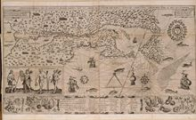](http://en.wikipedia.org/wiki/File:Samuel_de_Champlain_Carte_geographique_de_la_Nouvelle_France.jpg)

[http://bits.wikimedia.org/skins-1.18/common/images/magnify-clip.png](http://en.wikipedia.org/wiki/File:Samuel_de_Champlain_Carte_geographique_de_la_Nouvelle_France.jpg)

Map of New France made by Samuel de Champlain on 1612

The first structure of the town was a single large walled building, called l’Habitation. The difficulty of supplying the city from France and the lack of knowledge of the area meant that life was hard. Many people died of hunger and diseases during the first winter.

Initially, much of Nouvelle France was owned by a French government fur trading company, (much as parts of the future US were a possession of the East India Tea Company for a time). This company went out of business in 1662.

**French Territory (1663–1760)**

[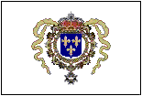](http://en.wikipedia.org/wiki/File:LouisXIV.gif)

[http://bits.wikimedia.org/skins-1.18/common/images/magnify-clip.png](http://en.wikipedia.org/wiki/File:LouisXIV.gif)

Seal of Louis XIV, used in the colony when the king determined New France to be a province of France. During this period, land was allotted to settlers using the **Seigneurie** **System**. In this system, land was divided into long, thin, lots along the river so that each settler could have access to the river for water and transportation.

**Picture:**

**British conquest (1756–1760)**

In the middle of the 18th century, [British North America](http://en.wikipedia.org/wiki/Colonial_America) had grown to be close to a full-fledged independent country, something they would actually become a few decades later, with more than 1 million inhabitants. Meanwhile [New France](http://en.wikipedia.org/wiki/New_France) was still seen mostly as a cheap source of natural resources, and had only 60,000 inhabitants. Despite their small population , Nouvelle France covered a larger area than the [Thirteen Colonies](http://en.wikipedia.org/wiki/Thirteen_Colonies).



The British Navy was the strongest military power of its time.



In the 1750’s war began between England and France for possession of Nouvelle France. The French military had early successes, but the tide began to turn when the British administration of [William Pitt the Elder](http://en.wikipedia.org/wiki/William_Pitt_the_Elder) decided to send military forces against the French colonies, while the British Navy controlled the Atlantic, preventing France from sending significant military assistance. In 1758, the British gained control of the mouth of the St. Lawrence River, and also took control of key forts on the frontier in battles at [Frontenac](http://en.wikipedia.org/wiki/Battle_of_Fort_Frontenac) and [Duquesne](http://en.wikipedia.org/wiki/Battle_of_Fort_Duquesne).

In the next phase of the war, begun in 1759, the British aimed directly at the heart of New France. [General James Wolfe](http://en.wikipedia.org/wiki/James_Wolfe) led a fleet of 49 ships holding 8,640 British troops to the fortress of Québec. They **disembarked** (**means**- got off the boat) on [Île d'Orléans](http://en.wikipedia.org/wiki/%C3%8Ele_d%27Orl%C3%A9ans) and on the south shore of the river; the French forces under [Marquis de Montcalm](http://en.wikipedia.org/wiki/Marquis_de_Montcalm) controlled the walled city and the north shore.

To siege means to surround and cut off all aid to. Once this happens, the “seiger” usually wins. It’s often just a matter of waiting until people in the surrounded city become hungry and desperate enough to give up.

Wolfe laid siege to the city for more than two months, exchanging cannon fire over the river, but neither side could end the siege. As neither side could expect resupply during the winter, Wolfe moved to force a battle. On 5 September 1759, after successfully convincing Montcalm he would attack from the east of the city, the British troops attacked from the west and successfully climbed the steep Cape Diamond undetected. Montcalm, no one knows why, did not use the protection of the city walls and fought on open terrain, in what would become known as the [Battle of the Plains of Abraham](http://en.wikipedia.org/wiki/Battle_of_the_Plains_of_Abraham). The battle was short and bloody; both leaders died in battle, but the British won easily. Now in possession of the main city and capital, and further isolating the interior cities of Trois-Rivières and Montreal from France, the rest of the campaign was only a matter of slowly taking control of the land.

**License plates on Quebecois cars often have the motto _________________________________ displayed on them. This means: _____________________. They mean that they remember the British victory at the battle of _______________________________, _____________ __________ and ________________.**

France was forced to cede (give up) all of Canada to the British at the [Treaty of Paris](http://en.wikipedia.org/wiki/Treaty_of_Paris_%281763%29).

**Québec Act (1774)**

The *Quebec Act* of 1774 was an [act](http://en.wikipedia.org/wiki/Act_of_Parliament) of the [parliament of Great Britain](http://en.wikipedia.org/wiki/Parliament_of_Great_Britain) setting procedures of governance in the [Province of Québec](http://en.wikipedia.org/wiki/Province_of_Quebec_%281763%E2%80%931791%29). Among other components, this act restored the use of the French [civil law](http://en.wikipedia.org/wiki/Civil_law_%28legal_system%29) for private matters while keeping the use of the English [common law](http://en.wikipedia.org/wiki/Common_law) for public administration (including criminal prosecution). This act reversed a previous law that had forced the Québécois to swear allegiance to the [Protestant](http://en.wikipedia.org/wiki/Protestant) faith guaranteeing free practice of the [Catholic](http://en.wikipedia.org/wiki/Catholic) faith. The purpose of this act was to encourage the loyalty of the French Canadians in the face of growing unrest in the American colonies.

**Canadian independence**

Canada became independent gradually and with the cooperation of the UK. Canada was proclaimed an independent nation on July 1st, 1867, however Canada still didn’t have the power to make changes to its constitution without British approval. In 1922, the Canadians started political actions to try to change this, but they were not given approval from Britain on this right until 1982.

**Relations with English-speaking Canada**

French-speaking Québec has existed uncomfortably with English speaking areas for many years. There has been much negotiation over the years, and yet English and French speaking Canadians frequently feel that the balance of power in Canada is tipped to favor the other group.

One attempt that was made to reconcile the Quebecois and the English-speaking Canadians was Law 101. This law said that all signs and labels must be written in French and in English . This law is frequently seen by English speakers as an example of how they have been more than generous to French- speakers because signs will usually be bilingual even in areas where most Canadians speak English.

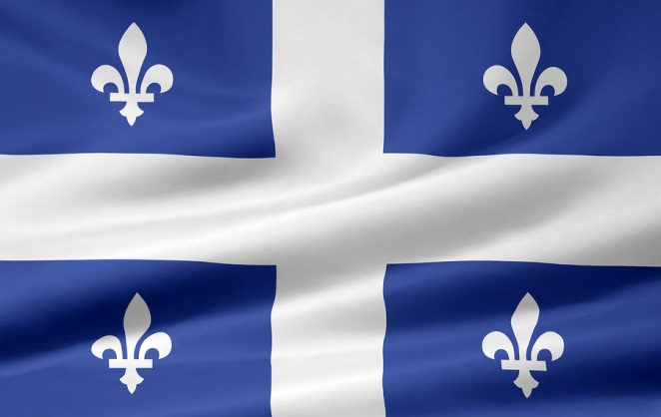

A referendum is when people vote on whether the government should take an action.

The province of Québec sought independence from Canada in referendums which took place in 1980 and 1995. On neither vote did les Québecois opt for a split from Canada.

**Québecois Culture**

Québecois culture is a mixture of Canadian culture, French culture, and is in some ways unique from both. Within Canada, les Québecois have the reputation of being heavy drinkers, having little money, dressing very casually and displaying dirty humor. It must be cautioned however, that these are stereotypes. On the other hand, the culture of Québec is very influenced by Catholicism.

Like many Canadians, les Québecois are involved in, or fans of, many winter sports- especially hockey. Like many French people, they tend to be very enthusiastic about the quality of their food.

Québec and its neighboring province, New Brunswick, are the only sizable regions in North America where French is an official language. There are also sizable French- speaking minorities in Nova Scotia and Ontario. There are isolated communities of French-speaking Canadians in other regions in Canada, like Alberta. There are even small communities of French speakers living in Massachusetts, Vermont, and Maine.

**Québecois superstition: Spiders**

* Throwing a spider under a cupboard will bring you luck and money.
* It is good luck to kill a spider with your right hand or foot. Likewise, it is bad luck to kill one with your left hand or foot.

**Les Filles du Roi**- means:

Early in its history Québec was populated mostly by Native Americans and French, male, fur trappers also known as couriers du bois (bois means wood, after their tendency to live in the woods.) Any French women around were often Catholic nuns. So there was a severe imbalance of mainly young, healthy males and eligible French women.

Interestingly, unlike men in the territory that would become the US, French-Canadian guys didn’t hesitate to marry and begin families with Native American women. Many male French settlers were unable to meet women at all. The French feared that the French population would move back to France or become assimilated into the Native Americans, and thus the territory would die out. So the French king, Louis XIV, sponsored the transport and settlement of 800 women who arrived between 1663 and 1673. These were the famous Filles du Roi.

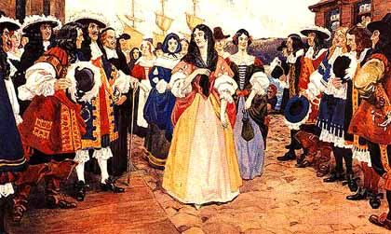

The women were often orphans, or had lost one parent, and were generally very poor, but were carefully selected by the French government for their strong moral character.

The women disembarked in [Québec City](http://en.wikipedia.org/wiki/Quebec_City), [Trois-Rivières](http://en.wikipedia.org/wiki/Trois-Rivi%C3%A8res), and [Montreal](http://en.wikipedia.org/wiki/Montreal). Because the ships carrying the ***filles du roi*** arrived at Québec first before going to Trois-Rivières and Montreal, the men of Québec had the first choice. This is still cited as the reason that women in Québec City are (allegedly) better-looking than their upstream sisters.

An early problem with the system was the women's adjustment to agricultural life. The ***filles du roi*** were mostly town girls, and only a few knew how to do farm work. This problem remained, but in later years, more farm women were recruited.