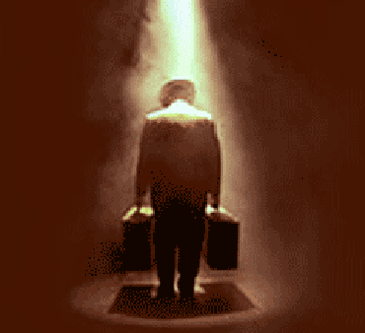

* What becomes of the American dream when the dreamer stops dreaming?
* When is it that great opportunities are disguised as impossible situations?

**Essential Questions:**

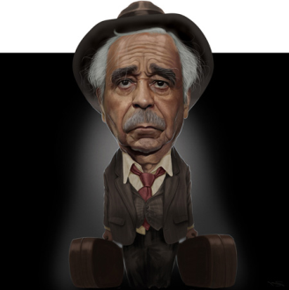

**Assignment Overview:**

* Choose one of the above essential questions
* Write, at minimum, a **two page** response in which you thoroughly answer your selected essential question
* Discuss the common connection between the play and the articles
* In answering the essential question, argue your stance by synthesizing both the play and the articles
* You will need to quote from every non-fiction article in the packet
* Proceed syllogistically
* Incorporate sufficient textual support and analysis