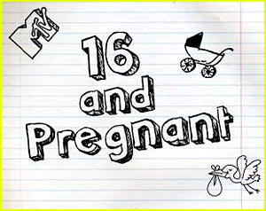

🖉 For this essay of 3 pages in length, we will view two episodes of MTV’s show “Teen Mom” and read seven articles. Based on these sources, you will need to develop a position: is the show irresponsibly glamorizing and romanticizing teen pregnancy – or conversely, does the show promote a healthy and responsible social message to teens?

☺ Here’s what you’ll need to do:

🖎 Develop a clear and focused position (thesis)

🖎 Use at least five of the seven articles

🖎 Synthesize the sources to argue your position

🖎 Proceed syllogistically

🖎 Provide plenty of textual support and analysis to defend your thesis

 **Links to Teen Mom Episodes**:

🖉 http://www.hulu.com/search?query=teen+mom&st=1