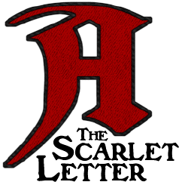

**Chapter Seven: The Governor’s Hall**

1. Once again, Hawthorne manipulates dark and light imagery in this chapter. Explain the effect it has and its significance.
2. Compare and contrast the rose bush in this chapter to the one we saw in Chapter One: The Prison Door.

**Chapter Eight: The Elf-Child and the Minister**

1. Hawthorne repeatedly references a bird in this chapter. What symbolic value does it hold?
2. Analyze and interpret the following line – “… the child finally announced that she had not been made at all, but had been plucked by her mother off the bush of wild roses that grew by the prison door.
3. Hester says that Pearl comes from “the hand of God” while the Governor says that “the little baggage hath witchcraft in her.” At this point in the story, is Hawthorne asserting that Pearl is good or evil?

**Chapter 9: The Leech**

1. Just as Pearl’s name takes on a greater value, so does Roger Chillingworth’s. Why do you suppose Hawthorne named his character as such?
2. Mr. Dimmesdale is repeatedly described as having his hand over his heart. Why?
3. Why is this chapter entitled “The Leech?”

**Chapter 10: The Leech & His Patient**

1. Dimmesdale’s heart is described with great detail. Why?
2. Why does Hawthorne spend so much time talking about weeds and plants?