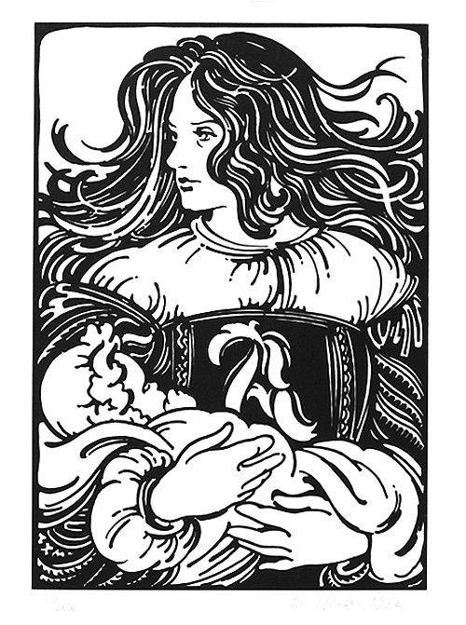

QUIZ 4

**Chapter 14: Hester and the Physician**

1. On page 91, Hawthorne once again spends a lot of time describing the character of Chillingworth. Analyze and interpret Hawthorne’s use of light and dark imagery on this page.
2. At the end of this chapter, the black flower is mentioned again. What purpose does it serve and why does Hawthorne use this symbol again?

**Chapter 15: Hester and Pearl**

1. Pearl makes a scarlet letter from seaweed. Why does Hawthorne do this? What purpose is he trying to achieve?
2. Analyze and interpret the following line – “Truly do I!” answered Pearl, looking brightly into her mother’s face. “It is for the same reason that the minister keeps his hand over his heart” (97).
3. The April breeze is described with great detail on page 97. Why? What is Hawthorne hoping to achieve?

**Chapter 16: A Forest Walk**

1. Analyze and interpret – “Mother,” said little Pearl, “the sunshine does not love you” (100).
2. Analyze and interpret – “As she attempted to do so, the sunshine vanished” (100).
3. Regarding the juxtaposition between light and dark imagery, analyze the story of the Black Man on pages 100 – 102.

**Chapter 17: The Pastor & His Parishioner**

1. Closely analyze the diction of the following paragraph – “Gathering himself quickly up …” (103).
2. Tear apart page 107. Look at the ironies, the tensions, the juxtapositions. What is Hawthorne’s purpose?