**Roth Technology**

**Grade 8 DeSimone**

**Lego Mindstorms Checklist**

Name: ________________ Grade: ________/100%

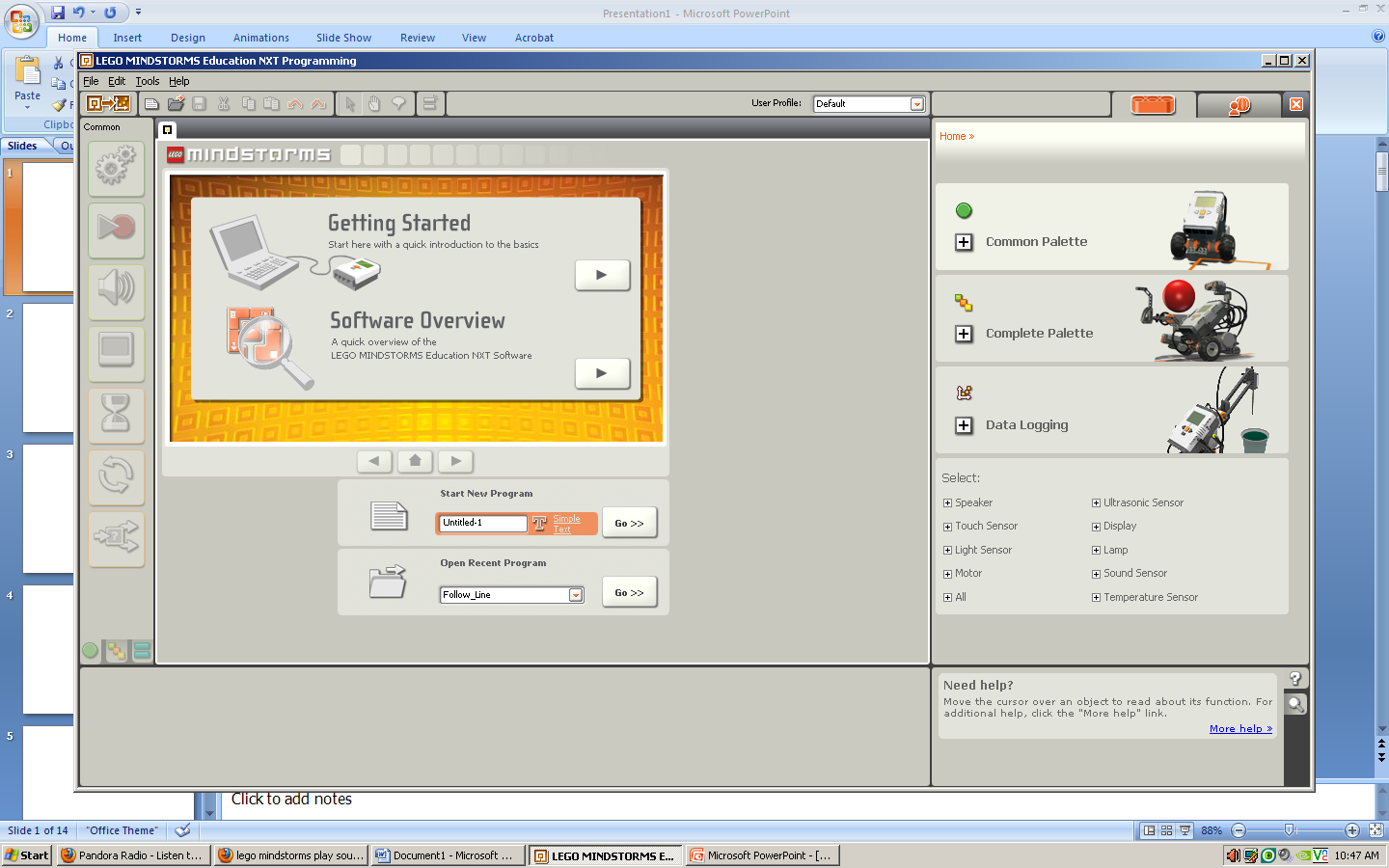**After completing each task from the ‘common pallett’ in order, please demonstrate for me and have each box checked off with my initials.**

