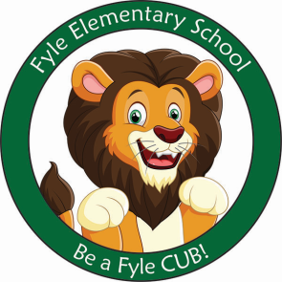

Mrs. Janofsky’s Weekly Update

June 7, 2019 WOW!!!!!

Math

Next week we will begin our last unit. This is a fun unit on shapes. Children are continuing to practice their addition and subtraction facts as well. Throughout the remainder of the year, we will review all concepts learned this year.

ELA

End of the year assessments are keeping us busy!

The last set of updated sight words came home this week. Please be sure to continue practicing daily. Reading bags will no longer come home. This does NOT mean nightly reading should stop. It is important that you continue to read with and to your child every night. In writing, we are having fun writing in a variety of ways. We are writing how to’s, narratives, and responding to literature. Each writing challenges students because they don’t all start with I. We have also completed our last unit in Fundations.

Social Studies

We have begun our last unit in SS. This week we discussed what a map is and began to discuss the parts of a map (scale, key, symbols, etc.). It has been exciting to see how much the children already know about maps and why people use them. Next week we will work to identify land and water on the map and where the US is located on the map.

Important Information

* Specials next week
  + Monday: C
  + Tuesday: D
  + Wednesday: A
  + Thursday: B
  + Friday: C
* Thank you for returning all of the library books before the due date!!!!
* Field Day is next Friday. We will be outside from 8:10-9:20. Lunch is at 10:30.
* Last day of school is approaching quickly. Our last day is June 25th. We will begin to discuss the transition to first grade. This may cause some nerves and uneasiness. Please let me know if you hear anything at home!

Sight Words

one

