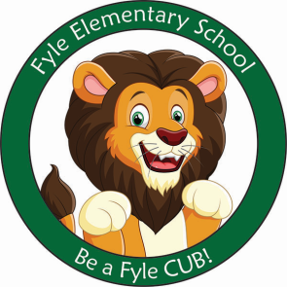

Mrs. Janofsky’s Weekly Update

December 7, 2018

ELA

We are down to just two more letters and sounds to learn! This week we worked with the letters and sounds of x and y. The children are very excited about being so close to the end. This week we have been identifying initial and final sounds of words. I have been very impressed with the children’s ability to isolate those sounds. This is an important skill for both reading and writing. In writing, we were introduced to something new this week. We worked on listening to a story and answering a question about it in writing. This was very challenging but we will continue to work on it.

Math

This week we have been learning how to compare the lengths of objects. We have compared objects using the language of longer, taller, and shorter. You can have fun doing this around the house. Have your child use an object ex., a spoon, and find things that are longer or shorter.

Hour of Code

The children participated in the Hour of Code this week. They learned about how a computer has to be taught what to do. We had some fun computer activities to learn this skill.

Important Information

* Specials next week:
  + Monday: B
  + Tuesday: C
  + Wednesday: D
  + Thursday: A
  + Friday: B
* Library on Wednesday. Please help your child remember their book!
* Sight words: Reminder we are working to both read and write the words.
* Thank you for helping the children with boots and coats. They are doing an AMAZING job!
* We completed our first community goal setting challenge with collecting 30 CUB cards.
* Many children are eager to make books at home. Please have them send them in to school. We are enjoying sharing our writing.

Sight Word

will go to

Reading Bags

Thank you for returning the reading bags on Wednesday! It is always exciting to get to this point in the year. A reminder….we are new to reading! Be sure to talk about the title and pictures before reading. It is important that the children point to each word as they read also. If your child becomes frustrated, feel free to read the book to your child and then have them read it.