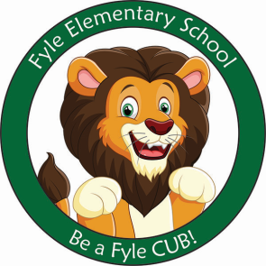

Mrs. Janofsky’s Weekly Update

October 4, 2018

ELA

The children are very excited about learning to read. This past week, the children have brought home a few new paper books. Please continue to encourage your child to read them to you. They should touch each word as they read. In Fundations, we have worked with the letter c and o this week. The vowel sounds (a,e,i,o,u) are difficult for children to remember. We have learned a hand sign to go with each of the vowels learned. Ask your child to show you. In writing, we are beginning to label our pictures. The children are encouraged to say the word for themselves and record the sounds they hear. At home, accept their “kid spellings.”

Math

We are busy learning to right numbers with proper formations. To date, we have practiced numbers to 7. Extra practice sheets were sent home for you to use. We are working hard not to have reversals.

Fire Safety

This week Fireman Mike came to visit and to help us learn ways to stay safe if there were to be a fire. He has given the children homework to learn their addresses and to determine a meeting place outside the house.

Important Information

* Next week’s letter schedule:
  + Monday: NO SCHOOL
  + Tuesday: D
  + Wednesday: A
  + Thursday: B
  + Friday: C
* Library on Wednesday. Please help your child remember their book!
* Get Acquainted Night on October 10th is for Grades 1-3. The Book Fair will be that evening if you would like to visit with your child.
* School Pictures on Thursday! If you are sending in payment for pictures, please be sure it is in the envelope that was sent home.

Sight Word

the

Halloween

As a school, we do not celebrate Halloween with costumes. The children are already eagerly talking about this event. However, please do not plan to send in costumes. The Parent Group sponsors a Boo Bash where the children may wear and show their costumes to friends. We will have other special activities to celebrate fall.