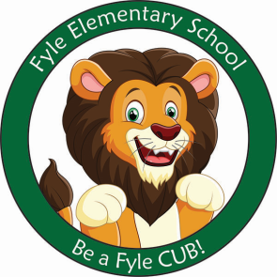

Mrs. Janofsky’s Weekly Update

October 26, 2018

ELA

This week we learned the nursery rhyme “Little Miss Muffet.” I hope your child has told you this rhyme. We wrote a connection to the rhyme writing about things we are scared of. We also wrote about places we think she might have run to. Our letters in Fundations this week were d and s.

Excitement about writing and being a writer is filling our classroom! We are busy writing books. Many children have made books at home and brought them in to share!!! We have loved celebrating our authors and illustrators. Continue to feel free to send the stories in.

Math

This week we began working with the concept of one less. We are also working to become flexible with math vocabulary ie., less and fewer meaning the same thing. Number practice has been sent home. Next week you will receive a review packet that you can complete to help practice skills taught in our first unit.

Ziploc Bags

This week your child brought home a bag with letters and/or words in it. This bag is to remain in your child’s folder. Letters/words will be changed about every two weeks. Please use the list of strategies that was included to help practice.

Important Information

* TONIGHT is Boo Bash.
* Next week’s letter schedule:
  + Monday: B
  + Tuesday: C
  + Wednesday: D
  + Thursday: A
  + Friday: B
* Library on Wednesday. Please help your child remember their book!
* As a school, we do not celebrate Halloween with costumes. The children are already eagerly talking about this event. However, please do not plan to send in costumes. The Parent Group sponsors a Boo Bash where the children may wear and show their costumes to friends. We will have other special activities to celebrate fall.
* **Book Orders due November 2**

Sight Word

Can

Ways to Support at Home

* Go to the Public Library and chose a book to read together.
* Have your child get their own library card.
* Go for a walk and bring a leaf home with you. Create a picture with it or paint it!
* Write letters and numbers on your child’s back with your finger and have them guess what you wrote. Switch places and have them do it to you.