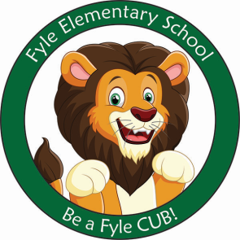

Mrs. Janofsky’s Weekly Update

February 8, 2019

ELA

Getting to know Eric Carle’s style of writing and creating his illustrations continues to be fun for all! This week we looked at a book called 1,2,3 to the Zoo. We enjoyed looking at the collages and the train at the bottom of each page. The Very Busy Spider led to a discussion on focus and ignoring distractions. We then wrote connections to things we are busy learning to do and have to ignore distractions while we learn. Our writing has moved to writing more than one sentence on a topic and making sure each sentence has SWAG. The children are getting better at editing their own work before asking me. At home, keep writing! Have them show you how to check for SWAG.

Math

Our new unit is well under way! Has your child explained a number bond to you? Be sure to look at the math sheets that come home and ask your child to tell you about the number bonds. I have been VERY impressed with the beginnings of this unit. With the ice delay, flashcards will not come home now until after February break.

Social Studies

Understanding the difference between a good and a service has been our focus this week. We are defining a service as something someone does for us ex., mechanics, haircuts and a good as something we can touch and hold ex., food or clothing.

Important Information

* Specials after break:
  + Monday: A
  + Tuesday: B
  + Wednesday: C
  + Thursday: D
  + Friday: A
* Library on Wednesday. Please help your child remember their book!
* February Break: No School the week of February 18th.
* 100th Day is on Thursday. Can you believe it???
* Reading bags come home every Tuesday and Thursday. Please be sure to return them completed the next day. I do reading conferences with the children on Wednesdays and use these books.

Sight Words

there are

Valentine’s Day

At Fyle, we call this day Caring Day. A letter with the information was sent home this week. Children may bring in cards. I am asking that they only sign them and do NOT address them to a specific child. We have 16 students and one should be brought for each person. Let me know if you have questions.