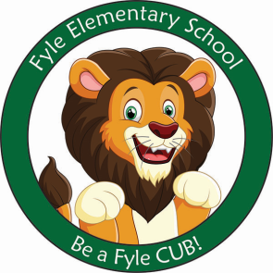

Mrs. Janofsky’s Weekly Update

March 1, 2019

ELA

Mercy Watson is a character in a series of books by Kate DiCamillo. This week we began reading the first book. The books are beginning chapter books and have provided a lot of suspense and disappointment over having to stop at a point and wait for the next day. It is helping us gain an understanding of the importance of remembering what we have read and being able to retell a story. In writing, we are working to increase our stamina and add additional sentences along with editing them for capital letters and punctuation. Editing your own work is not easy but the children are doing an excellent job.

Math

Number bonds, number bonds, number bonds! We continue to work on filling in different parts when given a whole and one part. We are working to understand there is more than one way to make a number. This week we also started playing around the world with addition facts. Today your child is bringing home flashcards to practice with. Subtraction is still VERY new but addition isn’t.

Science

Our new unit of study is on Properties of Solids and Liquids. This week we were introduced to the words and next week we will begin our exploration.

Sight Words

his

Important Information

* Specials next week
  + Monday: A
  + Tuesday: B
  + Wednesday: C
  + Thursday: D
  + Friday: A
* Library on Wednesday. Please help your child remember their book!
* March Recess: No School March 22nd.
* Reading bags come home every Tuesday, Wednesday, AND Thursday. Please be sure to return them completed the next day.
* At this time, all students should be counting to 100 by both ones and tens. I will be checking counting and sight words next week.

PARP

Please see the enclosed packet on information about next week’s PARP activities. Be sure to return your child’s reading slip each day beginning Monday. Start collecting those weekend minutes on Friday. Time that you read to your child along with them practicing reading counts. We are super excited about the possibility of earning an ice cream party!!! Happy Reading!!!!