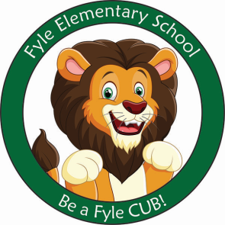

Mrs. Janofsky’s Weekly Update

September 28, 2018

Math

Making combinations and seeing hidden number partners is the beginnings of addition work. We have been working with the manipulatives and breaking them into parts. Number writing has increased to numbers to 6.

ELA

We have continued to work on reading the small books about colors. The children have been very excited that they are starting to read. This week we have started our new sight words. It is important that you are practicing the words at home. You can look for the words in books as you read. The children will have small paper books that they will bring home for most sight words. Have your child read the books over and over. Be sure to touch the words while reading. In Fundations, we are continuing to practice naming, writing, and making the sounds of t, b, f,m,n. This week we learned the first two vowels i and u.

Social Studies

This week we defined what a community is and discussed safety rules in different places in a community ie., playground, stores, restaurants. Please continue to have your child practice learning their address and a phone number as part of this unit.

Important Information

* Next week’s letter schedule:
  + Monday: D
  + Tuesday: A
  + Wednesday: B
  + Thursday: C
  + Friday: NO SCHOOL
* Library on Wednesday. Please help your child remember their book!
* Movie Night is TONIGHT!
* Spirit Week is next Week
  + Monday-Mixed Up Monday
  + Tuesday-USA Day
  + Wednesday-Sport Day
  + Thursday-RH Spirit Day
  + Friday-NO SCHOOL

Sight Word

see

Fyle E-News

Parents, please make sure that you are signed up to receive Fyle's newsletter that is sent out weekly by the building principal, Mrs. Mooney.  Each week Mrs. Mooney includes valuable information regarding the happenings in the building, upcoming events and Parent Group activities.

1.  Go to [rhnet.org](http://rhnet.org/)

2. Click on Schools

3. Click on Fyle

4. Scroll down to "E-News Subscriptions"

5.  Fill out the form.