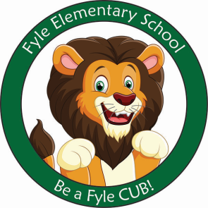

Mrs. Janofsky’s Weekly Update

May 31, 2019

Math

Next week we will be taking out unit assessment on teen numbers. The children continue to do a great job with this! We also continue to practice and adding and subtracting daily! We have one more unit in Math that will focus on shapes!

ELA

Over the next few weeks, we will continue to refine our skills in both reading and writing. The children are eager to show what they have learned and make work to be proud of! It continues to be fun to watch them as they talk about using strategies to help them. Yes, they do use the word strategy to explain! We will continue to work to put all of our skills together. Even with the nicer weather, it is important to keep routines going, read every day, and play outside. Please continue to read to your child every day!

Science/SS

This week we have been working with our PBIS traits especially focusing on caring. I hope you enjoyed the Helping Hand Coupon Book and will use the coupons that are included.

Next week we will begin our last unit on Maps and Globes. It is so hard to believe we are entering our final units!

Important Information

* Specials next week
  + Monday: B
  + Tuesday: C
  + Wednesday: D
  + Thursday: A
  + Friday: B
* Library has ended for the year! All books are due back for our class by Wednesday!
* Summer birthdays: Included in today’s folder is a note about coming to read to our class to celebrate your child’s birthday. Please let me know if that week works for you!
* Field Day is June 14th. A note came home in Thursday’s folder and is due back by Wednesday. We will participate in events from 8:10-9:20.

Sight Words

What, that

Chick Projects

Included in today’s folder is a computer project that was typed by your child about the chicks. There is also a packet included that we worked on throughout the unit. You will notice some pages aren’t completed as we did not have any chicks to use to complete those pages.