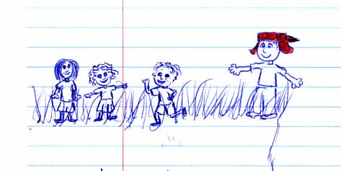

**Directions**

☺ In light of all the symbols we’ve studied during our analysis of *The Catcher in the Rye*, listen to the song “Watching the Wheels” by John Lennon. As we’ve discussed previously, Mark David Chapman murdered Lennon approximately 30 years ago. While Lennon slowly died as a result of the 5 gunshot wounds he received at the hands of Mark David Chapman, Chapman read passages from *The Catcher in the Rye* over Lennon’s fallen body.

🡺 Carefully analyze the lyrics of the song (Hint: Lennon’s song mentions several of the symbols that Salinger uses in *The Catcher in the Rye*).

🡺 Identify the symbols that Lennon uses in “Watching the Wheels” that are also used in the novel.

🡺 To what extent do the lyrics mirror the events of the novel?

🡺 Based on the lyrics and your understanding of the novel, why do you suppose Chapman felt compelled to kill John Lennon? **REFER DIRECTLY TO THE LYRICS & NOVEL TO SUPPORT YOUR POSITION.**

JOHN LENNON  
"Watching The Wheels"

People say I'm crazy doing what I'm doing,  
Well they give me all kinds of warnings to save me from ruin,  
When I say that I'm o.k. they look at me kind of strange,  
Surely you’re not happy now you no longer play the game,

People say I'm lazy dreaming my life away,  
Well they give me all kinds of advice designed to enlighten me,  
When I tell that I'm doing Fine watching shadows on the wall,  
Don't you miss the big time boy you're no longer on the ball?

I'm just sitting here watching the wheels go round and round,  
I really love to watch them roll,  
No longer riding on the merry-go-round,  
I just had to let it go,

People asking questions lost in confusion,  
Well I tell them there's no problem,  
Only solutions,  
Well they shake their heads and they look at me as if I've lost my mind,  
I tell them there's no hurry...  
I'm just sitting here doing time,

I'm just sitting here watching the wheels go round and round,  
I really love to watch them roll,  
No longer riding on the merry-go-round,  
I just had to let it go.

🡺 In the space provided below, identify the symbols and themes John Lennon uses in his song that directly allude to *The Catcher in the Rye.*

__________________________________________________________________________________________

__________________________________________________________________________________________

__________________________________________________________________________________________

__________________________________________________________________________________________

__________________________________________________________________________________________

__________________________________________________________________________________________

🡺In the space provided below, answer the following question: to what extent do the lyrics mirror the events in the novel?

__________________________________________________________________________________________

__________________________________________________________________________________________

__________________________________________________________________________________________

__________________________________________________________________________________________

__________________________________________________________________________________________

__________________________________________________________________________________________

🡺 Based on the lyrics and your understanding of the novel, why do you suppose Chapman felt compelled to kill John Lennon? **REFER DIRECTLY TO THE LYRICS & NOVEL TO SUPPORT YOUR POSITION.**

__________________________________________________________________________________________

__________________________________________________________________________________________

__________________________________________________________________________________________

__________________________________________________________________________________________

__________________________________________________________________________________________

__________________________________________________________________________________________

__________________________________________________________________________________________

__________________________________________________________________________________________

__________________________________________________________________________________________

__________________________________________________________________________________________