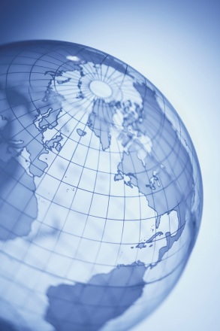Ich heiße__________________________________Heute ist_________

Directions: Use the GoogleEarth Tour and the websites provided to answer the following questions.

**Deutschland:**

1. How many countries border Germany? _____________________
2. What year was Germany First United? ______________________
3. How many years did the Cold war last in Europe? _____________

**Berlin:**

1. What Berlin symbol can be found painted all over the city? ____________
2. What is the name for the city center in Berlin? _______________
3. What is the name of the gallery with the largest section of the Berlin Wall? ________________________________

**Brandenburg Gate:**

1. Why was the Brandenburg Gate built? ______________________

**Reichstag:**

1. Who is the German Reichstag building dedicated to? ___________________________
2. How many degree view of the Berlin Cityscape does the dome on the top of the Reichstag allow? ___________________

**Fernsehturm:**

1. When was the TV tower built?__________________
2. What German company painted the TV tower in 2006 for the world cup?____________________________
3. List 2 functions of the TV tower in Berlin:________________

**Potsdam:**

1. Which king of Prussia built the palace of Sansousi as his summer residence? _____________________

**Bremen:**

1. List the names of the 4 animals in the story: _________________________________________________

**Hameln:**

1. List 5 famous Brother’s Grimm Fairy Tales you can find along the “Fairy Tale Road” in Germany: ____________________________________________________________________________________________________________

**Ruegen:**

1. What is the name of the most famous artist who painted the Chalk Cliffs? ____________________________________
2. Where in Germany are the Chalk Cliffs located? _____________________________