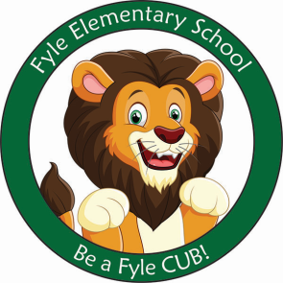

Mrs. Janofsky’s Weekly Update

November 2, 2018

Math

We finished our first unit in math. The children have done an excellent job on their assessments and have enjoyed special centers throughout the week. In today’s folder, you will find some extra practice sheets. This is NOT required and does not have to be returned to school.

ELA

“Hickory Dickory Dock” is the nursery rhyme of the week. With all of the special events of the week, we will continue to work with it next week too. Fundations letters of the week were e and r. We have now learned all of the vowels. They are very difficult and will remain a focus for a while. The children are beginning to “stretch words” to record more dominant sounds in words. At home, it is important that they practice saying words they want to write for themselves. Please accept their “kid spellings” of words. It is important that the children practice this way of writing.

Science

Our senses and fall were our focus throughout the week. We enjoyed our Senses of the Season activities on Wednesday. THANK YOU to Mrs. Buckley, Mrs. Collins, Mrs. Brennan, Mrs. Chiaraluce, Mrs. Haynie, and Mrs. Lepel for helping with these specials centers.

Important Information

* Next week’s letter schedule:
  + Monday: C
  + Tuesday: D
  + Wednesday: A
  + Thursday: B
  + Friday: C
* Library on Wednesday. Please help your child remember their book!
* Important Reminder! The children will be going outside for recess on days it doesn’t rain. Please be sure your child has hats and mittens as the weather changes.
* Please help your child practice putting their coat on, turning sleeves the right way, and zipping it.
* Clocks Change this weekend.
* Wednesday will be read a shirt day. Wear a shirt that has a word or letters on it!

Sight Word

My

Sight Word Bags

Just a reminder that sight word/letter bags should be kept in your children’s folders. Next week I will be checking the letters/words using the bags. Please be to return them to the folder over the weekend.