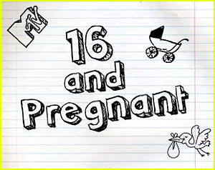

🖉 For this essay of 3 pages in length, we will view two episodes of MTV’s show “Teen Mom” and read four editorials. Based on these sources, you will need to develop a position: is the show irresponsibly glamorizing and romanticizing teen pregnancy – or conversely, does the show promote a healthy and responsible social message to teens?

☺ Here’s what you’ll need to do:

🖎 Develop a clear and focused position (thesis)

🖎 Use at least four of the six sources

🖎 Synthesize the sources to argue your position

🖎 Proceed syllogistically

🖎 Provide plenty of textual support and analysis to defend your thesis