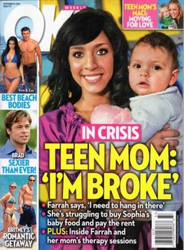

**SOURCE FOUR**

**Teenage mothers see pregnancy as a 'career move'**

Girls as young as 13 decide that parenting offers a better life than dead-end jobs, says new report

By Sophie Goodchild and Jonathan Owen

Teenage girls who get pregnant are deliberately "planning" to become mothers in the belief that a baby will improve the quality of their lives.

An extensive study published today reveals that girls as young as 13 are making a "career choice" by deciding to have children, since they see parenting as preferable to working in a dead-end job.

The findings from the Trust for the Study of Adolescence challenges the assumption that schoolgirl mothers are all irresponsible adolescents who are ignorant about using contraception. The revelation that teenage girls are actively choosing motherhood is backed up by official figures obtained by this paper which show that nearly a quarter of pregnancies to under 18s are second children.

The research will have huge implications for government policy, which gives little acknowledgement to the fact that some girls see motherhood as the right decision for them. Britain has highest teenage pregnancy rate in Europe, with an estimated cost to the Government of at least £63m a year. The parts of the country that have most teenage births are areas of poverty and high unemployment; girls from low-income families are 10 times more likely to become teenage mothers than those from affluent backgrounds.

The research, funded by the Joseph Rowntree Foundation, was based on interviews with 13- to 22-year-old mothers living in six deprived parts of Britain who had either taken a fatalistic attitude to getting pregnant by stopping taking contraception or who had actively planned to have a child with the support of their partners.

All the interviewees were well aware how to protect against pregnancy and were strongly anti-abortion. Nearly three-quarters were in steady relationships with the father of their child. Only a handful of girls said they regretted getting pregnant. The vast majority said their lives had improved after having children, that having a baby had "corrected" their deprived childhoods and turned them away from destructive behaviour such as drink and drug abuse.

Experts say that the truth about planned teenage pregnancies has been masked until now because health workers often assume they happen accidentally and because young girls tend to keep their true motives secret.

The study's authors are calling on ministers to use sex education classes to highlight the fact that fertility is at its highest in adolescence. They hope to target girls who leave pregnancy to chance by offering them alternatives and to use those who have had negative experiences to educate others about the downsides. But they also pose the question whether teenage pregnancy should always be avoided, given the positive experiences of the girls surveyed.

Aimee Marsh did not intend to get pregnant at the age of 15 but had discussed the possibility with her 18-year-old boyfriend, Lee. Their baby daughter, Demi-Leigh, was born 13 days ago and Ms Marsh, now 16, is planning to have three children in total, though she intends to wait until she is 25. "It is not as hard as I thought it would be," says Ms Marsh, from Plymouth, who hopes to go to college to do a hair and beauty course. "There is still some prejudice around young mums, but you can have kids at any age as long as you enjoy life and it brings you happiness."

However, ministers have rejected the report's suggestion that teenage pregnancy can be a positive option, saying it invariably leads to "negative consequences for all concerned".