**Article written by Suzy Osbourne**

The economy as we all know is pretty bad. Although we read about the economy on the web, newspapers and magazines and catch the latest news on TV and radio, sometimes the best way to gain insight on a particular subject is through images. Graphs are an amazing way to analyze data and current situation. Today we have compiled a few graphs that shows the current economic situation that we are in.

The graph below analyzes job losses during 1990, 2001 and current recession. Hundreds and thousands of people are being laid off daily and unemployment rate is record high. Take a look at the graph below, it sure is scary

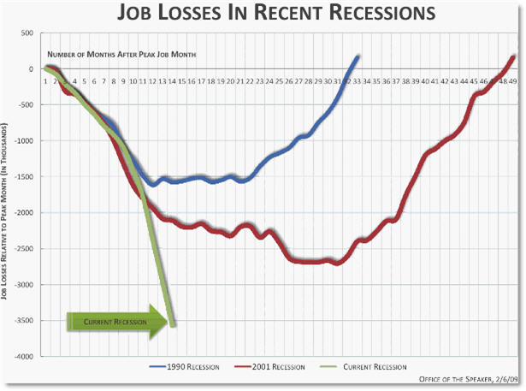

The number of students dropping out of high school is significantly higher as compared to past years.

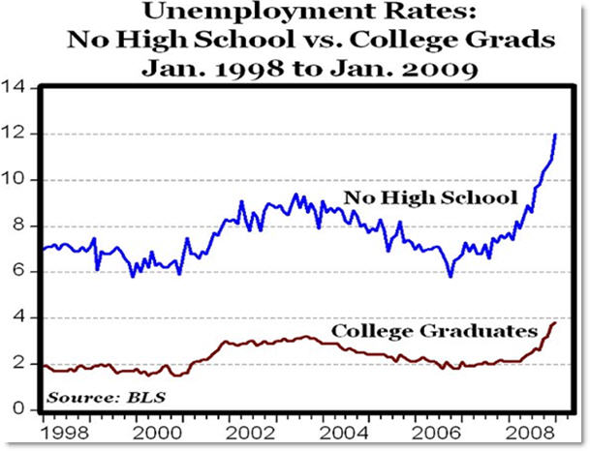

Although we already know that the unemployment rates are higher than ever, this graph gives us an idea as to where we are sitting in terms of unemployment.

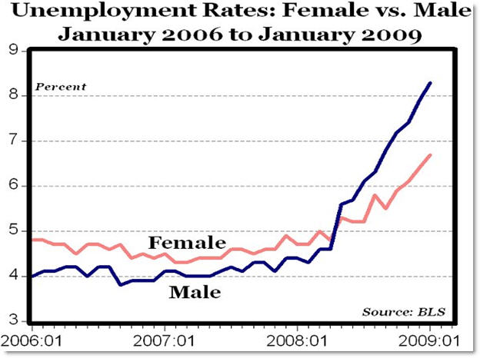

The graph below shows weekly unemployment claims which gives a clear view of today’s job market

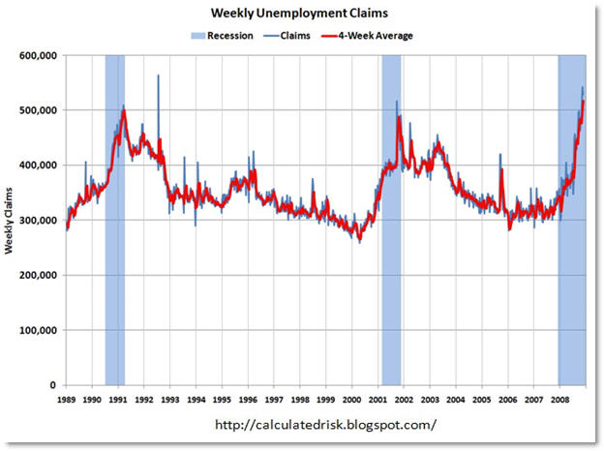

Now that we have looked at the job market, lets take a look at other aspects of the economy. The graph below shows no. of bank failures since 1934

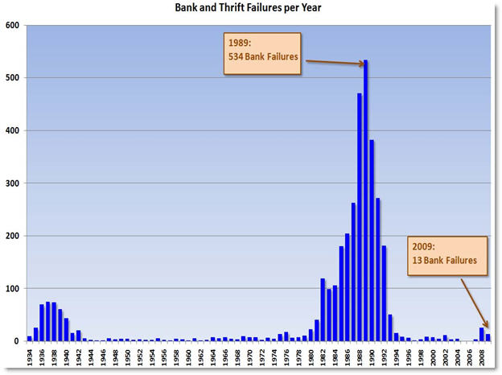

Bank failures by total assets and deposits per year since 1934

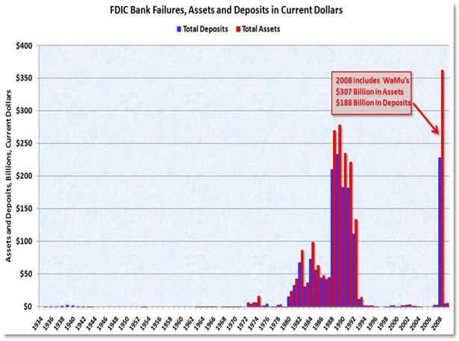

Let’s take a minute and look at where we stand in terms of trade ~~surplus~~/deficit,

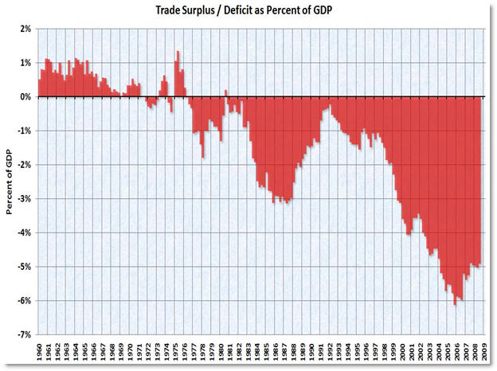

Time to take a break from the graphs. Ever wondered what the share of each US citizenÂ  is to the outstanding public debt? Here you go,

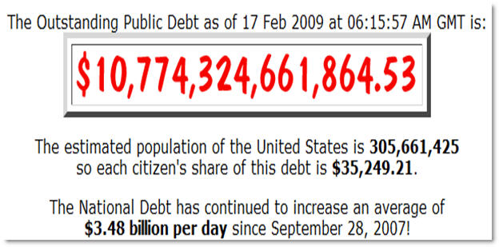

If you think that is scary take a look at the forecast below

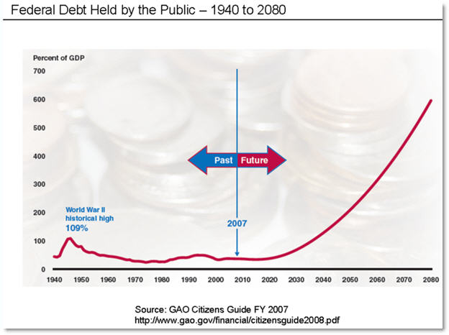

We Americans tend to spend quite a bit. In September 2008 [NY Times released a finding](http://www.nytimes.com/interactive/2008/09/04/business/20080907-metrics-graphic.html?th&emc=th) that showed Americans are the biggest spenders.So what did they spend the most on and how much?

* $429.8 billion on clothing and footwear
* $162.0 billion on electronics
* $205.6 billion on alcohol and tobacco
* $456.9 billion on household goods
* $881.0 billion on recreation

Now that the economy is going down the hill, how are Americans adjusting to the economy? By cutting spending in one way or the other. According to a poll conducted by [Gallup](http://www.gallup.com/Home.aspx), Americans have cut down their spending by 40% compared to last year.

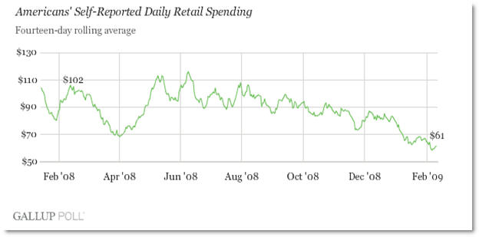

And finally the general outlook on US economy

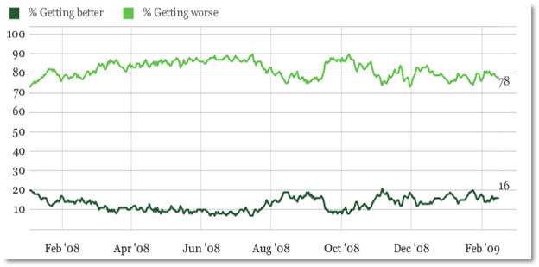

Although the general outlook towards the economy isn’t very good, we are sure it will get better. The main thing we all need to realize is that it won’t be a quick recovery. Let us all hope for the best and do our part in restoring the economy.

If you have written anything related to the economy or would like to share your thoughts, please feel free to comment or drop a link to your article.