The Crucible
Reader’s Response Journal
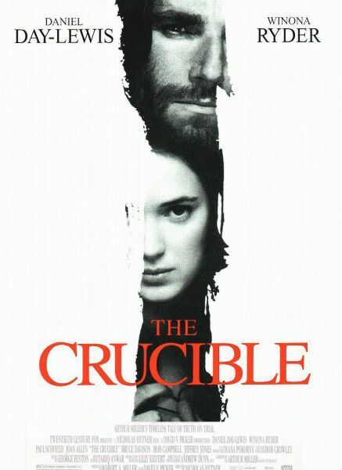

Name ____________________________________________

Name ______________ The Crucible
Reader’s Response Questions
Act One

Directions:
• Respond to 5 questions for this entry. Each response should be accompanied with at least 3-5 sentences of commentary.

- "So now they and their church found it necessary to deny any other sect its freedom, lest their New Jerusalem be defiled and corrupted by wrong and deceitful ideas." What is the irony of that statement?

- Explain how the witch hunt years were a time of "general revenge."
- Why does Mrs. Putnam believe there are witches in Salem? Why is Thomas Putnam bitter? How might this motivate them in the pursuit of witches?
- Parris says "Oh, Abigail, what proper payment for my charity! Now I am undone!" What does that mean?
- Describe Proctor. What happened between Abigail and John Proctor prior to the opening of the play? What are the implications, especially considering the setting of the play?
- Explain the political relationship between the Putnam and Nurse families.

- What effect does Rebecca have on Betty?

- What is Rebecca's explanation of the girl's behavior?

- "There are wheels within wheels in this village and fires within fires." Explain.
- Parris demands firewood, the deed to his house and more money. What does he really want?

- Giles says, "Think on it now, it's a deep thing, and dark as a pit." To what is he referring, literally and symbolically?

- What do Putnam and Proctor argue about? What does this show?
- Hale says, "They (the books) must be (heavy); they are weighted with authority." What is the significance of this remark?

- To what did Tituba confess? Why?
Name ______________ The Crucible
Reader’s Response Questions
Act Two

Directions:
• Respond to 5 questions for this entry. Each response should be accompanied with at least 3-5 sentences of commentary.

- Where does Elizabeth want John to go, and what does she want him to do there? What is John's response to her prodding?

- What was the “evidence” against Sarah Good? Do you think this is sufficient evidence to prosecute her? Why or why not?

- Why doesn't Proctor want Mary to go back to court? Would you if you were her? Why or why not?

- Why does Elizabeth think Abigail wants to kill her?
- What things are "suspicious" about Proctor and his family? Explain how each of these suspicions may be misinterpreted.

- Hales asks Elizabeth if she believes in witches. What is her reply? Why is this important?

- Explain the significance of the needle in the "poppet."

- What will happen to Proctor if he tries to discredit Abby? How is he in a no win situation?

Name ______________ The Crucible
Reader’s Response Questions
Act Three

Directions:
• Respond to 5 questions for this entry. Each response should be accompanied with at least 3-5 sentences of commentary.

- What paper did ninety-one people sign? Why did they sign it?

- "A person is either with this court or he must be counted against it, there be no road between." Explain the importance of Danforth's statement.

- What quote did Proctor use to help Mary remain brave? Explain the significance. What is the irony?

- Hawthorne thinks of a test for Mary. What is it? Can she do it? Why or why not?

- Proctor calls Abigail a whore, and he confesses his lechery. Danforth tests Proctors statement by calling for Elizabeth and asking her why Abigail was dismissed. What does Elizabeth say? Why?

Name ______________ The Crucible
Reader’s Response Questions
Act Four

Directions:
• Respond to 5 questions for this entry. Each response should be accompanied with at least 3-5 sentences of commentary.

- What explanation does Cheever give Parris' "mad look"?

- What did Abigail do? Why is this so significant to the events in Salem?

- Parris says, "You cannot hang this sort. There is danger for me." What "sort" does he mean, and what is the danger to him?

- Explain Danforth's reason that a pardon would not be just.

- Why has Hale come back to Salem? What does Hale want Elizabeth to do? Why?
- What happened to Giles? Why is his demise significant?

- Proctor says, "My honesty is broke, Elizabeth, I am no good man." Explain. Do you agree? Is Proctor past saving?

- What did Proctor do after he signed the confession? Why?

- What "confession" did Elizabeth make to John?

- Proctor says, "I have given you my soul; leave me my name!" Explain.

- Elizabeth says, "He have his goodness now. God forbid I take it from him!" What does she mean?

