FOUNDATIONS OF ART SYLLABUS 2016-2017
RHCSD - NINTH GRADE ACADEMY– JULIE FLISNIK
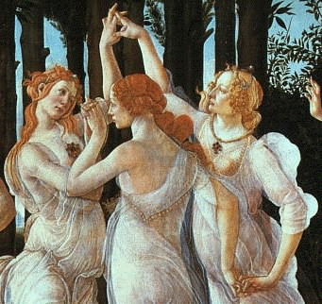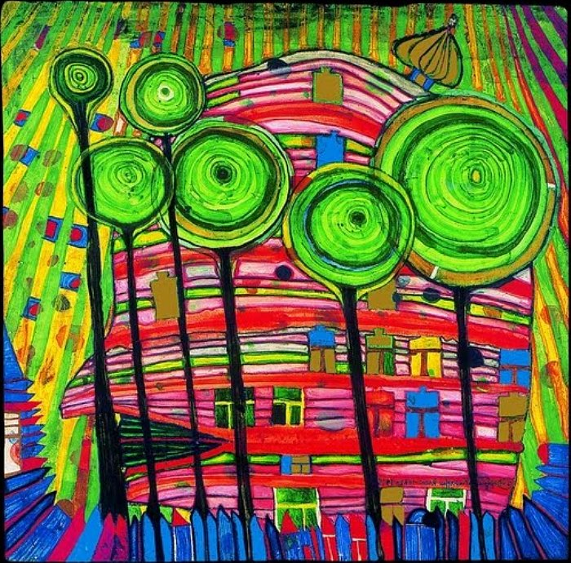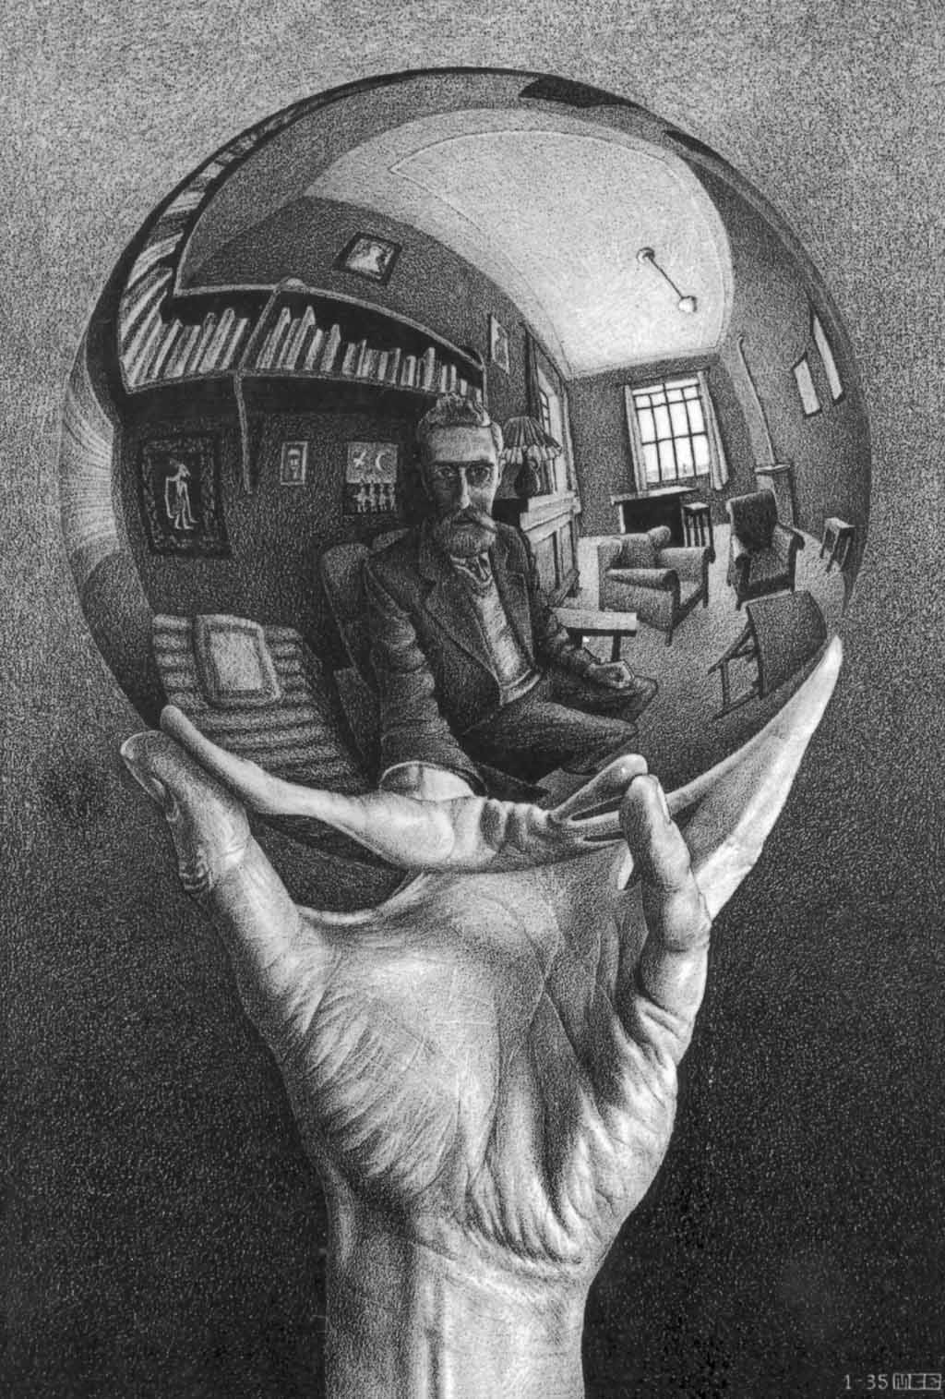
DaVinci Botticelli Hundertwasser Escher

Course Description:
Foundations of Art is an introductory level art class. It is a full year class. It fulfills the state mandated one unit of art or music to graduate. Lessons in this course are designed in accordance with the Visual Arts Learning Standards as outlined by the RH School District and NYS. Students will be given the opportunity to learn through drawing, painting and sculpting activities. The curriculum has been recently revised. The revised curriculum includes digital integration as a key component. (In other words, students will use the computer to make art too.) In a nutshell, students will make, look at, critique and write about art.

My thoughts on learning in my ART Classroom:
EVERYONE can MAKE ART. I have observed this to be TRUE over and over again in my years teaching students of ALL ages. I believe TALENT to be overrated. A student’s attitude, work ethic, perseverance and interest are much more powerful determinates of their ability to be successful.

Course Objectives:
Foundations of Art students work on a variety of exercises and projects to further develop:
- Technical skills of drawing, painting, sculpture and digital imaging
- Conceptual and creative thinking
- Personal creative expression
Foundations of Art classes are engaged and challenged by:
- Structured and directed exercises designed to teach technical art skills, artistic understanding and personal expression
- Creation of a digital portfolio of the work created this year

Classroom Policies:
Assessment: All work will be assessed using the Foundations of Art rubrics. Students will be made aware of the LEARNING OUTCOMES as they are outlined in the rubrics in the beginning of each instructional unit. Satisfactory completion of all REQUIRED COURSE ASSESSMENTS is necessary to earn a passing grade for this course.

Classroom Policies continued:
Make – up work: Students are expected to make up all assigned work. Students are responsible for obtaining make-up work the next class day after they return to
school. If the student’s absence is excused they will have one week to complete outstanding work. If it is unexcused it will be due the following class day.
In the event of an incomplete grade:
* Student and Instructor will develop a plan of action to rectify the incomplete in a timely manner.
* Overall averages will not be calculated
* Academic points will not be rewarded
* Student will not be allowed to participate in Sports, Extra-Curricular Activities, and Honor Societies
Attendance: Students are expected to attend class regularly and be on time. The NGA policies in these areas will be enforced and parents/guardians will be notified after the third tardy.
Behavior: Positive mature attitudes towards one’s work, as well as respect are critical to a successful year in Foundation of Art. In general, any behavior that is disruptive or disrespectful will be addressed.
Studio Maintenance: There are 6 different classes occurring within this one studio space so it will be critical for each individual artist to maintain any supplies they use as well as the space where they sit. The NGA art supply budget is not infinite. Caring for permanent supplies such as brushes, rulers, erasers, etc. is critical. Keep things clean and take personal responsibility in putting your supplies away! Failure to comply with basic behavioral and supply maintenance will result in a discussion, phone call home and if the behavior persists a discipline referral.
Cell Phones and other Technological Devices: The students will have access to a portable MAC mobile lab in my classroom all other technology including cell phones are not allowed in my class.

Additional Information:
I have 20 + students assigned to my learning lab daily. I will take a maximum of 5 additional students during that time to work on assigned course work. You must have a pre - signed pass to come to my lab. Passes must be obtained before NOON on the day you wish to come in.
Please feel free to contact me with any questions or concerns at any point during the year. I am very excited to be working with you!
Email: jflisnik@rhnet.org

I have read, understand and have no questions regarding the above document.

Parent Signature & Date

Student Signature & Date

