October 2015

Dear Parent(s):

Your child has expressed an interest in participating in the 2016 Monroe County School Music Association sponsored solo and ensemble festival. Festivals are scheduled for:

January 8-9, 2016 - Senior High Instrumental (grades 9–12) at Fairport Minerva Deland (Friday 6–9 p.m.) & (Saturday 9 a.m. – 4 p.m.)

January 8-9, 2016 - Vocal Solo Festival at Gates Chili HS

January 15-16, 2016 - Junior High Instrumental (grades 7–8) Brighton - Twelve Corners MS
(Friday 6–9 p.m.) & (Saturday 9 a.m. – 4 p.m.)

January 22-23, 2016 – Elementary (grades 4-6) Instrumental & Instrumental Jazz (grade 7-12) at Pittsford – Barker Road MS (Friday 5–8 p.m.) & (Saturday 9 a.m. – 4 p.m.)

The solo festival is an invaluable experience for students, evaluating three different areas of performance; scales, a prepared solo, and sight-reading. The certified adjudicator is a specialist who will record constructive comments on the student’s performance. Solos range in difficulty from I–VI.

The district will provide an accompanist for the student when appropriate, but the parent is responsible for the registration fee of $12.00 for solos Level 1 - 4; $18.00 for solos Level 5 & 6, provide an original copy of the solo (photo copies are not allowed), and provide transportation to and from the festival site.

Please remember, once your child has committed to attend this festival, he/she must attend. Thank you for your support. Should you have any questions, please contact your child’s music teacher or the district music office.

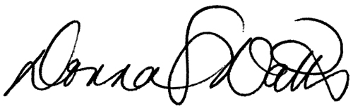
Sincerely,

Donna S. Watts
Director of Music and
Visual Arts Education

DSW:ag
Attachment

