Oedipus the King
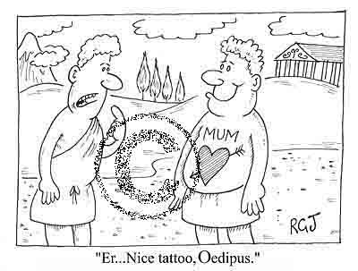
Textual Tours: Play

Directions:
☺ Choose from one of the following prompts listed below and write a 2 page critical response of Oedipus the King. As always, type your paper and email your rough draft to …

kristian_kuhn75@yahoo.com

♦ Critic Roland Barthes has said, “Literature is the question minus the answer.” Considering Barthes’ observation, write an essay in which you analyze a central question the work raises and the extent to which it offers any answers. Explain how Sophocles’ treatment of his central question affects your understanding of the work as a whole. Avoid mere plot summary.

♦ Many works of literature not readily identified with the mystery or detective story genre nonetheless involve the investigation of a mystery. In these works, the solution to the mystery may be less important than the knowledge gained in the process of its investigation. With regards to Oedipus, consider how he confronts his mystery. Then write an essay in which you identify the mystery and explain how the investigation illuminates the meaning of the work as a whole. Do not merely summarize the plot.

♦ Morally ambiguous characters – characters whose behavior discourages readers from identifying them as purely evil or purely good – are at the heart of many works of literature. Consider Oedipus’ moral ambiguity. Then write an essay in which you explain how the character can be viewed as morally ambiguous and why his moral ambiguity is significant to the work as a whole. Avoid mere plot summary.

