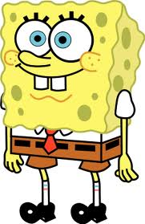
Position Paper
 For this essay of 3 pages in length, we will view two episodes of Nickelodeon’s show Spongebob Squarepants and read five editorials. Based on these sources, you will need to develop a position: is the show inappropriate for kids to watch?
☺ Here’s what you’ll need to do:
 Develop a clear and focused position (thesis)
 Use at least three of the sources
 Synthesize the sources to argue your position
 Proceed syllogistically
 Provide plenty of textual support and analysis to defend your thesis

