The Catcher in the Rye

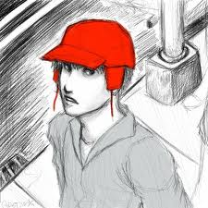
Critical Lens
Your Task:
Write a critical essay in which you discuss The Catcher in the Rye and another text from the particular perspective of one of the statements listed below. In your essay, provide a valid interpretation of the statement, agree or disagree with the statement as you have interpreted it, and support your opinion using specific references to appropriate literary elements from the two works. You may use scrap paper to plan your response. Write your essay on separate sheets of paper:

Critical Lens: ONLY BASE YOUR ESSAY ON ONE OF THE FOLLOWING STATEMENTS
 “Fear always springs from ignorance.”
- Antoine Exupery
OR
 “All literature shows us the power of emotion. It is emotion, not reason, that motivates characters in literature.”
- Henrik Ibsen
OR
 “All literature is protest. You can’t name a single literary work that isn’t protest.”
- John Henry David Smith

GRADING CRITERIA: MAKING SURE ALL THE ESSENTIAL INGREDIENTS ARE INCLUDED
□ Provide a valid interpretation of the critical lens that clearly establishes your thesis statement and criteria for analysis
□ Indicate whether you agree or disagree with the statement as you have interpreted it
□ Make specific references to appropriate literary terms (theme, conflict, characterization, setting, point-of-view, etc)
□ WRITE 2 SYLLOGISMS PER BOOK!!! THIS IS A 6 PARAGRAPH ESSAY!!!

