Literature Circle
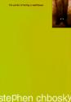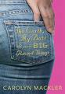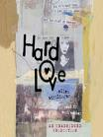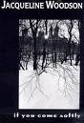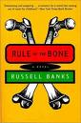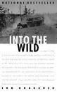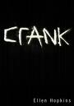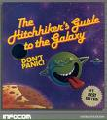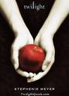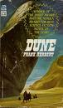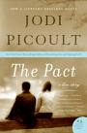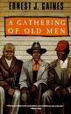

Book Club

Assignment Overview
◊ A few weeks ago the English department administered a reading interest survey and the data revealed two things: students are more likely to read when they have a choice in the text selection, and students prefer to read texts that touch upon their personal interests (no duh… and we needed a survey to figure that out). This unit will allow you to choose from amongst a “plethora” of titles covering a wide array of topics and genres. Listed below are the criteria for the unit:
□ Reader’s Response Journal and Book Club Discussions (400 pts)
• Each night your Book Club group will be assigned a set number of pages to read. It is imperative that all members fulfill their reading obligations so that they can be active and intelligent members. This portion of the unit will consist of:
◊ Reader’s Response Journal
- For every section of text you are assigned, you will need to respond to 5 questions in your journal. Please follow the same format we’ve used all year (NOTE: EACH GROUP MEMBER MUST COMPLETE THEIR OWN JOURNAL. AS ALWAYS, YOU WILL RECEIVE NO CREDIT FOR COPYING ANOTHER STUDENT’S WORK)

◊ SPECIAL NOTE: Reader’s Response Journal
- Several of the selections do not have prepared packets of Reader’s Response questions for every section of text you are assigned. If this is the case for your title, you are to respond to the five best questions from your Entrance Tickets. You will be assessed on the quality of these questions and your responses. The questions should reflect your deep understanding of the text and the depth of your critical analysis.

◊ Entrance Tickets
- Upon entering class each day, students will need to submit 3 questions and/or passage explications based on the previous nights reading. These tickets need to be completed before the bell rings in order to receive credit. More importantly, the tickets will help you to facilitate discussion. It’s important, therefore, that all group members ask good questions and complete their work on a nightly basis. In the past, students have used this as an opportunity to cheat. If you are caught cheating, you will receive no credit for the this portion of the unit!!

◊ Subjective Maturity Checks
- Managing a classroom is a lot easier when we are all reading the same text, but I am placing my trust in you that discussions will maintain a mature focus and that all members will pull their weight. While discussions are occurring, I will frequently monitor groups and assess your productivity, engagement with the text, and the group’s sense of cohesion. Don’t make me baby-sit you, otherwise an alternative assignment will be made available to you

◊ Exit Tickets
- At the end of every class period, I will monitor your progress with regards to the journal. You will have plenty of time to complete your journals in class and it is my expectation that you will do so. Please be prepared to submit an entry everyday of the unit

◊ Independent Reading Time
- Each class I will devote approximately 20 minutes of class time for independent reading. Your grade for this is simple to calculate: are you using the time to read?
My expectation is that during this time the classroom will be absolutely silent. in addition, if you choose to venture off to your locker or dilly-dally in the bathroom, you will receive no credit for this portion of the unit

◊ Word Slam
- As you read your selected text, inevitably you will encounter words that you don’t know. Every day before the bell rings, I want one member from each Book Club to place one word, its definition, and a contextualized sentence on the board. The words and sentences should come directly from your book. It’s the group’s responsibility to assign wordsmiths each day. Once we have 20 words, we will have a Word Slam quiz.

▫Critical Lens Essay (100 pts)
●In order to prepare you for the Regents Exam in June, we will write a Critical Lens essay using a past exam whereby you analyze two texts (your Literature Circle text and another book), ground your thesis in the themes of the lens, use textual support from recall, and analyze relevant literary devices.
▫Free Verse Essay (100 pts)
●As a group, Literature Circle members will devise a writing prompt. All of the texts lend themselves nicely to analysis, but as a group you will need to determine what is worthy of further exploration. For example, the group that is reading The Perks of Being a Wallflower, you might want to write a cross analysis of the oft-referenced song by the Smith’s entitled “Asleep,” and analyze how the lyrics relate to the book. Or, for the group reading Johnny Got His Gun, maybe you could analyze the song “One” by Metalica and determine how the lyrics mirror the events in the novel. Apart from song connections, maybe a group could formulate their own essential question and respond to it through textual analysis. Whatever your group decides, the point is that I’d like to see some stellar textual analysis. Just to throw out more ideas, maybe the group reading The Earth, My Butt … could juxtapose the photos and advertisements in an issue of a teen magazine to determine is the fundamental claims contained in the book hold water. The sky is the limit, so shoot big.
▫ Group Tangible Object Project (100 pts)
●Since this is group effort, I’m expecting something BIG, something Herculean, something grandiose that reflects your collective understanding of the book. All members need to be actively involved in the making of the object. Just to throw out some ideas, maybe you could make a black & white silent movie of the key moments in the novel, or write and perform a song, or a video montage, or a webpage, or a newspaper … who knows … but shoot big. The objects will be displayed to the class via an informal presentation arrangement.

