Mr. Kuhn
11R English
Rush-Henrietta Senior High School
kkuhn@rhnet.org
Kristian_kuhn75@yahoo.com
359-5200 ext. 1125 or voicemail 1826

The Earth, My Butt, and Other Big Round Things
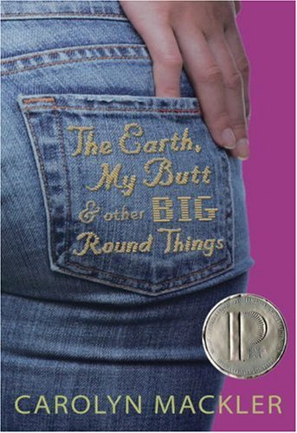
Unit Overview & Grade Breakdown
Literature Circle

Essential Questions:
What are the barriers to true self-hood?
What are the perfections of being flawed?
What is the weight of carrying too much weight?
Where is the pride in making others proud?

Individual Tasks
♦Reader’s Response Journal
Keep a Reader’s Response Journal that characterizes your thoughts and reactions to the texts we will be reading throughout the unit. Your responses should demonstrate thoughtful engagement with the text. Although you will receive a grade on your ten (10) best entries, all entries need to be completed. You will be graded in accordance to the Reader’s Response Journal Rubric. Please follow the format and guidelines that are listed in Mr. Kuhn’s examples. (100 points)

♦ Harkness Discussion
Needless to say, I can’t facilitate seven different discussions simultaneously. That being said, groups will need to develop and run their own Harkness Discussions. Keep in mind that your diversion activity (Jenga, Hungry Hippos, Group-Made Board Game, etc.) is to serve two functions: an opportunity to complete your Reader’s Response Journal as well as to offer a commercial break from your discussion so that you can refocus. The diversion activity needs to be quick, quiet, and appropriate for the classroom. Prior to each class, you and your group must plan for the next Harkness Discussion. I will grade these discussions on a daily basis (100 Points)

♦ Critical Lens Essay
I will provide you with a list of over 25 former Critical Lens statements from past exams. You can choose any prompt to base your response. This is an individual assignment, so your group does not need to settle upon one lens statement. Please adhere to the “recipe” when baking this delicious essay (100 points)

♦ Entrance Tickets
Upon entering class each day, students will need to submit 3 questions and/or passage explications based on the previous nights reading. These tickets need to be completed before the bell rings in order to receive credit. More importantly, the tickets will help you to facilitate discussion. It’s important, therefore, that all group members ask good questions and complete their work on a nightly basis (100 points)

♦ Subjective Maturity Checks
Managing a classroom is a lot easier when we are all reading the same text, but I am placing my trust in you that discussions will maintain a mature focus and that all members will pull their weight. While discussions are occurring, I will frequently monitor groups and assess your productivity, engagement with the text, and the group’s sense of cohesion. Don’t make me baby-sit you, otherwise an alternative assignment will be made available

♦Exit Tickets
At the end of every class period, I will monitor your progress with regards to the journal. You will have plenty of time to complete your journals in class and it is my expectation that you will do so. Please be prepared to submit an entry everyday of the unit. On a different note, your attendance is crucial for the overall success of a Literature Circle. If you are not in class, you obviously are not contributing in a meaningful and productive manner. Your grade will be reflected as such. So, to my lovely students who need beauty sleep, look ugly the next couple of weeks because your grade and your group are depending on you (Combined with Subjective Maturity Checks = 100 points)

♦ Essential Question Paper
This essay will be composed in class and will require you to respond to one of the above essential questions. You will also need to provide plenty of textual support to defend your thesis position. (100 Points)

♦ Vocabulary Journal
I am asking that everybody keep a vocabulary journal for this unit. Simply look up words you don’t know, provide a definition for each word, as well as a sentence that uses the word correctly in context, and place these words in your journal. (100 points)

♦ The Poetic Seventh
As part of our classroom routine to prepare you for the Regents Exam, we will begin each class by analyzing a poem. Over the course of the unit we will read a wide range of poems that address the content and standards of the exam. After having received the seventh poem, you will be assigned a task that directly mirrors a portion of the exam. (100 points)

♦ Group Tangible Object Project
This assignment will allow you to demonstrate your understanding of the text in a medium of your preferred choosing. By tangible I simply mean something that can be experienced by any of the five senses. Your project can take any form or shape. Students in the past have composed songs, made short films, constructed collages, or creative writing samples. I will provide you with a packet listing at least 55 options. Since this is a collective enterprise, shoot big (100 points)

