Bone’s Song
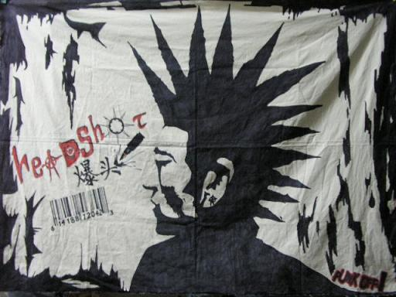
Rule of the Bone
½ way “BIG TEST”

Directions:
♦This test will assess your engagement with the text thus far. Here’s what you need to do:

□ Choose a song that best captures the essence of who Chappie/Bone is as a character
□ Write a minimum of a one page essay whereby you explain how the song lyrics mirror the life of Chappie/Bone (Note: I fully expect all of you to write more than the minimum)

□ Your essay needs to have a unifying thesis that connects Rule of the Bone and the song lyric

□ Include at least 2 quotes from Rule of the Bone and be certain to thoroughly analyze the song lyrics

□ Please provide a copy of the song lyrics

□ Since this is 11R, sprinkle some literary terms into your essay


This ain’t your grandmommy’s rock-n-roll!!

