Misery
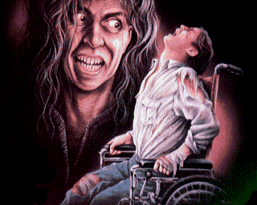
Reader’s Response Journal
Entry #8
Pages 284-338

Directions:
☺ Respond to 4 questions for this entry. Please follow the suggested format.

- Paul continuously ruminates the following song lyrics – “Burn the mother down” (284-287). Unpack this thought with reference to his current predicament.

- How does the following recollection impact Paul’s current conflict: “I didn’t kill him, you know. You killed him. If you had kept your mouth shut, I would have sent him on his way. He’d be alive now …” (299).

- Analyze and interpret: “The fact was simple: he wanted to take care of Annie Wilkes himself. They could only put you in jail, bitch, he thought. I know how to hurt you” (294).

- Analyze and interpret: “The fact that he had been searching for traces of a hotshot writer named Paul Sheldon was reported, but Kushner’s disappearance had not been linked, even speculatively, with Paul’s own. At least, not yet” (295).

- Explain Paul’s silence on pages 296-298. Why doesn’t he alert the police officers? Use a quote to help support your answer.

- Explain the reason for Paul’s cynical thought: “Well, if you want to know for sure, just check the six o’clock news, he thought, and then had to raise both hands to mouth to plug up the giggles” (300).

- Annie poses a seemingly innocent question of the media – “You know what they want?” (301). What does the media want according to Annie?

- Analyze and interpret Paul’s conflict: “I think I am going to kill you, Annie, he thought, and smiled warmly at her. I really do. I may go with you – probably will, in fact – but I am going to go with a by God bellyful of caviar. Things could be worse” (308).

- Paul pleads with Annie to smoke a cigarette upon completion of Misery’s Return. Why does Paul make this request? Use a quote to help support your answer.

- After Paul’s attempted murder of Annie, why does Paul find himself locked in the bathroom?

- Analyze and interpret the following scene: “She was dead,’ Paul said. ‘I knew it – the real part of my mind did – but I can still hardly be … (327)

- Does Paul kill Annie? Use a quote to support your answer.

- Analyze and interpret: “That was all in the past, though. Annie Wilkes was in her grave. But, like Misery Chastain, she rested there uneasily. In his dreams and waking fantasies, he dug her up again and again. You couldn’t kill the goddess. Temporarily dope her with bourbon, maybe, but that was all” (336).

- Despite having escaped from Annie, Paul still ponders – “Paulie, Can you?” (337). Why?

- The novel ends with Paul weeping while he writes. Why does the act of writing move him to tears?

