Fat Kid Rules the World
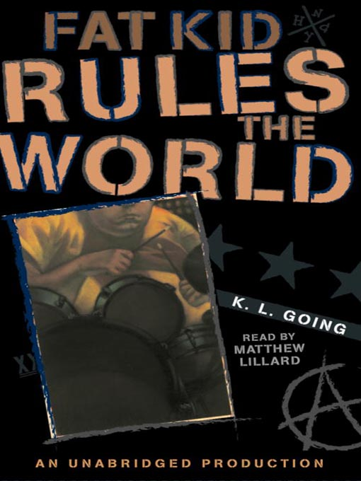

Reader’s Response Journal
Entry #4
Pages 100-140

Directions:
• Respond to 5 questions for this entry. Each response should be accompanied with at least 3-5 sentences of commentary and placed in your Readers Response Journal. Please follow the suggested format.

1. Analyze and interpret the underlying conflicts of the following statement: “You just breathed in a lot of the sweet night air …” (101)

2. Unpack Ollie’s diction and what he’s implying to Troy: “Lots of people can’t do that. They’ve got to turn him into something he’s not. But you … I think you might be the one” (102)

3. On page 104, Troy details the morning after the concert. What is ironic about his father’s reactions?

4. Analyze and interpret: “I’m looking for the Curt that was on stage. The one who was so honest it was painful. The one who seemed like a rock star …” (107).

5. Analyze and interpret the tension and exchange that causes the following reaction: “I lean back in my chair and let my jaw drop to the floor. To my knowledge, it’s the most defiant thing anyone my age has ever said to him” (110).

6. Troy announces, “I am the Rocky Balboa of obese drummers” (113). With his new determination, do you think he’ll reach his goal? Why?

7. Analyze and interpret Troy’s sentiment and apparent conflict: “It’s the moment in my life I’ve been waiting for ever since I gained weight. The cameral zooms in, the music swells, the crowd does the wave. I want to laugh or cry, or laugh and cry, but in the end …” (115)

8. Explain Troy’s preoccupation in the following scene: “Hey Ollie, when’s Curt coming back? (118).

9. Analyze the “pie incident” on page 119 from Troy’s perspective.

10. In chapter 56 on pages 120-121, analyze the source of Curt’s “grumpiness.”

11. How might the following exchange serve as a moment of foreshadowing – “what’s this new thing we’re going to do” (122)?

12. On pages 124-125, Curt and Troy are immersed in a power struggle
a). What’s Curt’s strategy?
b). Who wins the struggle? Explain

13. Analyze and interpret: “I’m sitting on the toilet with my head in my hands, but I look up slowly” (127)
a). Why is Troy in the bathroom?
b). What is significant about his “look up”?

14. To what extent is Curt’s advice exactly what Troy needs to hear – “Maybe you’re too self-conscious sometimes. Maybe you’re thinking about yourself instead of the song … possibly” (129)?

15. Analyze and interpret Troy’s conflict: “It’s a good speech and I want to respond. I really do. But I’m …” (129)

16. Analyze and interpret Troy’s sentiment: “I’ll be faking it. The weatherman predicts a zero percent chance of confidence today. Its hateful with a chance of suicide” (130).

17. Based on contextual clues on page 132, why doesn’t Troy play the first song?

18. To what extent has Troy missed his first performance – “This is the worst day of my life. I try to remember every horrible day just to be sure …” (134).

19. Following the first performance fiasco, Troy quarantines himself. How does the conversation with Ollie on pages 135-136 change Troy’s point of view?

