Misery
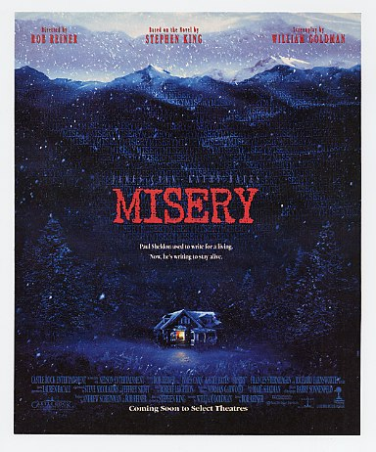
Reader’s Response
Entry # 3
Pages 61-90

Directions:
• Respond to 5 questions for this entry. Each response should be accompanied with at least 3-5 sentences of commentary and placed in your Readers Response Journal. Please follow the suggested format.

- Based on the events exchanged between Paul and Annie on pages 61-62, to what extent do writers play God?

- Explain the context and reasoning surrounding Annie’s thoughts: “Well, honestly! I knew writers were supposed to have big egos, but I guess I didn’t understand that meant ingratitude too!” (62).

- With regards to writing Misery’s Return Paul suggests: “It makes us even”(64).
  - Does he truly believe this?
  - What is Annie’s perception of this?

- Analyze and interpret the “frown” and “grin” in the following exchange between Paul and Annie: “I wonder if you could turn that typewriter around. So it faces the wall.’ She frowned. ‘Why in the world would you want me to do that?’ ‘Because I don’t want it grinning at me all night’”(65).

- Stephen King details Paul’s dream in pages 65-66. What is his intent in doing this? Moreover, what does the dream reveal about Paul?

- Explain the irony of Annie’s comment to Paul: “And my mother always used to say that the hope of spring is like the hope of heaven” (69).

- Annie’s characterization often correlates her to natural elements like the moon. Why does Paul characterize her in the following manner: “The climate inside her, he had come to discover, was like springtime in the Midwest. She was a woman full of tornadoes waiting to happen, and if he had been a farmer observing the sky which looked ...”(70)?

- What exactly does Annie mean when she requests: “Don’t call it that. I hate it when you call it that ... When you pervert the talent God gave you by calling it a business. I hate that” (72)?

- On page 72 Annie and Paul describe the nature of Paul’s “whoredom.” Examine the debate from both character’s perspectives.

- Based on the context, why do you suppose Annie says, “There is one thought I would like to leave you with. You may think you can fool me, or trick me; I know I look slow and stupid. But I am not stupid, Paul, and I am not slow” (75)?

- Paul makes a big fuss about the typewriter paper. Why? What is his ulterior motive?

- Analyze and interpret the following passage: “So you just sit there and you think about who is in charge here, and all the things I can do to hurt you if you behave badly or try to trick me. You sit there and you scream if you want to, because no one can hear you. No one stops here because they all know Annie Wilkes is crazy, they all know what she did, even if they did find me innocent” (75).
  - What prompts Annie to snap?
  - She alludes to her innocence. Why? What does she mean?
  - Who has the upper hand in this scene? Explain

- Analyze and interpret Paul’s desperation: “Please, God, please. Please, God, please – let me out of this or kill me” (76).

- Explain Paul’s thought process in the following event: “I just can’t believe the guts this Sheldon kid is displaying today! ...” (76-77).

- Analyze and interpret: “He grasped both wheels and got the chair moving again. This time he rolled five feet before stopping to straighten himself out. Once he’d done it, he grayed out” (77).

- Paul recollects a comment that his mother frequently made: “There may be fairies, there may be elves, but God helps those that help themselves” (79). What bearing does this recollection have on Paul’s present predicament?

- Writing Fast Cars has been a blessing and a burden for Paul. Based on pages 79-81, how has the act of writing such a novel proven to be a blessing?

- Analyze and interpret: “Her voice called him out of his daze. He opened his eyes and saw she was pointing a shotgun at him. Her eyes glittered furiously. Spit shone on her teeth. “If you want your freedom so badly Paul,’ Annie said, ‘I’ll be happy to grant it to you.’ She pulled back both hammers’” (82).

- Analyze and interpret Paul’s sentiments: “He looked around quickly, chin down on his breastbone, eyes crafty and frightened. Although he knew it was too soon to be feeling any relief, he did feel it – having the pills, it seemed, was even more important than taking the pills. It was if he had been given control of the moon and the tides – or had just reached up and taken it” (85).

- In the following scene, what prompts or motivates Paul’s thought process: “But if it had! his mind screamed back. If it HAD! Please, you have to go back to your room before you leave something ... a track ....” (88).

- Paul escapes from the guest room. Why doesn’t he pick up the phone and notify the police of his situation and whereabouts? Use a quote to help support your answer.

- Earlier in the chapter Paul implored God to be on his side. Why might he think God listened to him based on the following passage: “He had nearly finished the turn when he heard an approaching car and knew, simply knew it was her, returning from town” (90)?

