The Catcher in the Rye

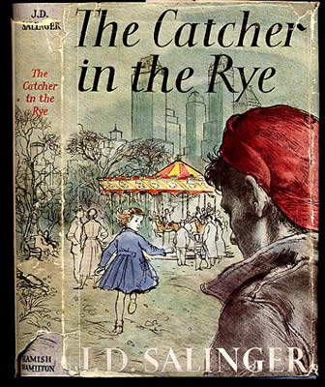

Readers Response Questions
Chapters 8-12
Entry #3

Directions:
• Respond to 2 questions for each chapter. Each response should be accompanied with at least 3-5 sentences of commentary and placed in your Readers Response Journal. Please follow the suggested format.

Chapter 8

- Holden tells us, “If I’m on a train at night, I can usually even read one of those dumb stories in a magazine without puking. You know. One of those stories with a lot of phony, lean-jawed guys named David in it, and a lot of phony girls named Linda or Marcia that are always lighting all the goddam David’s pipes for them”(53). Why is it that Holden can tolerate phoniness on a dark train at night?

- Why do you suppose Holden tells Ernest Morrow’s mother that his name is Rudolf Schmidt?

- Holden tells the reader that Ernest Morrow “was doubtless the biggest bastard that ever went to Pencey”(54). Why, then, does he tell Ernest’s mother so much flattering stuff about her child?

- Holden ostensibly invents a new character for himself when he talks with Mrs. Morrow. He states things like his name is Rudolf; he has a brain tumor; he’ll be spending the summer in South America with his grandmother, etc. Why does he feel the need to lie?

Chapter 9

- Holden tells us that the first thing he did when he got to Penn Station was go to the phone booth. He considers calling DB, Phoebe, Jane Gallagher, Sally Hayes, and Carl Luce.
  - Why does he feel the need to place a phone call?
  - What ultimately motivates his decision not to call anybody?

- Holden often wonders about the ducks in Central Park. He asks a cab driver, “You know those ducks in that lagoon right near Central Park South? The little lake? By any chance, do you happen to know where they go, the ducks, when it gets frozen over? (60). Why is Holden so enticed and captivated by the ducks?

- Analyze and interpret Holden’s viewpoint of the following event: “in my mind, I’m probably the biggest sex maniac you ever saw. Sometimes I can think of very crumby stuff I wouldn’t mind doing if the opportunity came up. I can even see how it might be quite a lot of fun, in a crumby way, and if you were both sort of drunk and all, to get a girl and squirt water or something all over each other’s face. The thing is, though, I don’t like the idea. It stinks if you analyze it”(62).
  - Why is Holden sexually conflicted with the scene he witnessed at the hotel?
  - He says that he doesn’t like the idea and that it stinks. Why?

- Analyze and interpret Holden’s sentiment: “Sex is something I just don’t understand. I swear to God I don’t”(63).

- Holden made a promise to himself that he wouldn’t pursue phony girls. Is he breaking his promise by chasing Faith Cavendish? Use a quote to help support your answer.

Chapter 10

- What does the following remark reveal about Holden: “That’s the thing about girls. Every time they do something pretty, even if they’re not much to look at, or even if they’re sort of stupid, you fall half in love with them, and then you never know where the hell you are”(73)?

- Holden continually calls the three girls in the Lavender Room ignorant, phony morons. How might they perceive him to be the real ignorant, phony moron?

Chapter 11

- Analyze and interpret the following passage: “She was pretty young, but she had this terrific figure, and I wouldn’t’ve put it past that Cudahy bastard. She said no, though. I never did find out what the hell was the matter. Some girls you practically never find out what’s the matter”(79).

- Based on Holden’s story, state at least 3 things that make Jane an authentic human being.

Chapter 12

- How might the following statement about the Central Park fish be an analogy that makes a statement about society: “They live right in the goddam ice. It’s their nature, for chissake. They get frozen right in one position for the whole winter”(82)?

2. Based on the quotation in question #1, is Holden more like a fish or a duck? What’s his nature? Explain.

