The Absolutely True Diary of a Part-Time Indian
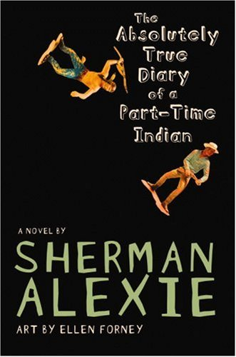
Reader’s Response Journal
Entry #5
Pages 179-230

Directions:
• Respond to 5 questions for this entry. Each response should be accompanied with at least 3-5 sentences of commentary and placed in your Readers Response Journal. Please follow the suggested format.

1. Analyze and interpret: “I suppose it had something to do with confidence. I mean, I’d always been the lowest Indian on the reservation totem pole. I wasn’t expected to be good so I wasn’t. But in Reardan, my coach and the other players wanted me to be good. They needed me to be good. They expected me to be good. And so I became good” (180)

2. Examine the sentiment that underlines the following comment: “And I was kind of suspicious that white people were really interested in seeing some Indians battle each other. I think it was sort of like watching dogfighting, you know? It made me feel exposed and primitive” (184).

3. Of the upcoming basketball game against Wellpinit, Junior says – “I feel like this is the most important night of my life” (186). Why is he placing so much stock in this one game?

4. As Junior contemplates guarding Rowdy, he thinks to himself – “So many ghosts” (188). What does he mean by this?

5. Unpack what Junior means by the following line – “I mean, you have to love somebody that much to also hate them that much, too “(191)

6. Explain the biblical allusion of Junior’s epiphany – “I realized that my team, the Reardan Indians, was Goliath” (195).

7. Why is it significant that Junior “yukes” after the game instead of before the game?

8. Examine Junior’s sense of sarcasm in the following line: “Yep, so let me pour a drink for Tolstoy and let him think hard about the true definition of unhappy families” (200)

9. With regards to the events on page 201-202, consider one of our essential questions – “To what extent are tragedy and privilege congenital traits?

10. Consider Junior’s rhetorical question – “Yep, how Indian would that be? (203)?

11. Examine the source of Junior’s laughter on pages 204-205.

12. Analyze and interpret the symbolic implications of the cantaloupe on page 205

13. Explain the logic of Rowdy’s accusation – “Your sister is dead because you left us. You killed her” (211). Does he have a point?

14. Analyze and interpret: “Reservations were meant to be prisons, you know? Indians were supposed to move onto reservations and die. We were supposed to disappear. But somehow or another, Indians have forgotten that, reservations were meant to be death camps. I wept because I was the only one who was brave and crazy enough to leave the rez. I was the only one with enough arrogance” (217).

15. Examine the litany on page 217. What function does it serve?

16. Analyze and interpret the symbolic significance of the Stupid Horse story. What bearing does this story have on the book as a whole?

17. The tree climbing scene is recounted on pages 224-226. What bearing does this story have on the book as a whole?

18. Analyze and interpret: “You’re an old-time nomad. You’re going to keep moving all over the world in search of food and water and grazing land. That’s pretty cool” (230).

