The Earth, My Butt, and Other Big Round Things
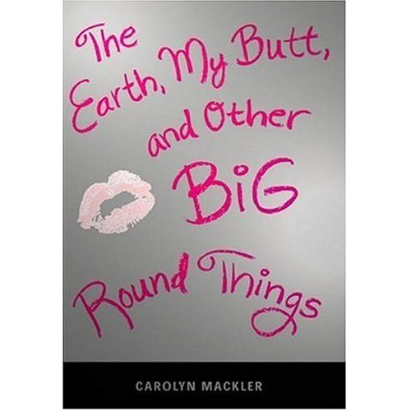

Reader’s Response Journal
Entry #5
Pages 110-150

Directions:
• Respond to 5 questions for this entry. Each response should be accompanied with at least 3-5 sentences of commentary and placed in your Readers Response Journal. Please follow the suggested format.

1. Analyze and interpret the tension in the following scenario: “I’m still processing the fact that they’re not in this country. They go to Connecticut almost every weekend, rain or shine, sleet or hailstorms. They even went last spring when I won a creative writing award …” (112).

2. What prompts the following reaction and is it healthy or self-destructive: “A few times I caught sight of myself in my new mirror, cramming food into my mouth …” (113)?

3. Based on pages 113-114, is Virginia the kind of friend you would want to have? Support your answer with the text.

4. Virginia finally confides in her mom and breaks down. Her mom asks, “You’re having a hard time with this, aren’t you?” (117). Is the “this” of the mom the same “this” that is troubling Virginia?

5. Analyze and interpret the source and effect of Virginia’s thought processes: “When the party wound down, Byron invited her back to …” (120)

6. Analyze and interpret the source of Virginia’s confusion – “This is so confusing. For as long as I can remember, I’ve looked up …” (120-121)

7. Based on pages 122-123, how has Byron’s date rape served as a wedge in the relationship between Virginia and Froggy?

8. Pick apart the various reasons why Virginia feels the following way – “I want Froggy to go away. I need Froggy to go away. If he hangs …” (124).

9. Based on page 126, why doesn’t Virginia feel comfortable telling her English teacher the issues that are plaguing her?

10. Answer the following question from Virginia’s and her mother’s perspective – “If that’s the case, then why should Byron’s ordeal affect what I do for Thanksgiving” (130)?

11. Based on pages 132-133, why is it that Virginia has so much compassion for Annie Mills and very little for Byron?

12. Analyze and interpret the contradiction and conflict in the following exchange: “But what about Thanksgiving -.” “Virginia,’ mom says, ‘We’re talking about completely different circumstances” (135).

13. What are the double implications of the following question – “What’s that smell? Does something smell funny in here?” (136)?

14. On page 138-139, Virginia tries on seven different occasions to write a letter to Anais. Why are these letters flawed and what do they reveal about Virginia?

15. Unpack and answer all of Virginia’s “what ifs” – “What if for one second I didn’t care what people thought about me? What if I weren’t so eager to please mom and dad? What if I didn’t always try to blend in, go with the flow, be the good, obedient girl?” (143).

16. On page 148-149, Virginia prepares to tell her parents that she will not be home for Thanksgiving, but in Seattle. What is “choking” her and why in both a literal and figurative sense?

