The First Part Last
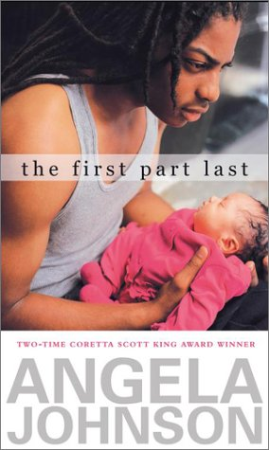

Reader’s Response Journal
Entry #4
Pages 87-131

Directions:
• Respond to 5 questions for this entry. Each response should be accompanied with at least 3-5 sentences of commentary and placed in your Readers Response Journal. Please follow the suggested format.

1. In the following paragraph, is Bobby’s brother Paul being condescending, supportive, or indifferent: “Paul looks sorry for me. He’s the only one …” (93)?

2. Explain and analyze the source of “shock” Bobby’s mother’s gesture carries on pages 93-94. Moreover, is she being a good mother to Bobby and a good grandmother to Feather?

3. Bobby, in conversation with his brother, mocks Fred by saying – “You know, the kid with the baby needs to be treated like one” (95). Is there truth to Bobby’s sarcasm?

4. Based on page 97, what does Bobby “lose” if they decide to put the baby up for adoption and if they do not?

5. Unpack the diction of Bobby’s self conflict: “It’s the right thing. Everybody says so, and I want to believe the shit everybody says, I want to believe it’s unselfish. I want to believe none of this is supposed to be about me” (98)
a). What’s the “right thing” and how right is it according to Bobby?
b). What is the “shit” everybody is saying and why is it that Bobby
doesn’t buy into it.

c). If it is not about Bobby, who is it about and why?

6. On page 98-99, Bobby doesn’t seem to have much say in the baby’s fate. Why is this?

7. Analyze and interpret the mom’s perspective and Bobby’s reaction to it: “Mom always shut hers tight. She says so she wouldn’t be tempted to do what most grandmothers would do. Take over” (100).

8. On page 101 Bobby witnesses his mom crying:
a). Why is she crying. Use the text to support your answer.
b). Analyze and interpret her reaction to Bobby’s question as to
why she is crying.

9. Analyze and interpret: “We decided the other day, it would all be over” (105). What is all over?

10. Analyze and interpret: “I look at them and feel like I’m missing something. Then I think – I got K-Boy and JL. I mean not like before. But I still got them. It’ll never be like before, but I still got ‘em” (110).
a). What is Bobby missing, if anything?
b). In this passage, does Bobby seem to regret his decision?
c). Is his friendship with K-Boy and JL secure? Explain

11. Based on page 111, do we gain any further insight as to why Nia isn’t involved in parenting Feather?

12. On pages 114-115, we receive an account from Nia:
a). Why does she use the conditional tense (should, would)?
b). Explain the repetition of flying
c). Nia references blood. What’s going on with her?

13. Based on page 117, consider the following:
a). What happened to Nia?
b). Does Bobby really want to be a father? Support your answer
with the text.

14. Analyze and interpret: “But it didn’t matter what was going on, baby; I kept telling her about you. Damn right, I kept telling her about you” (118).

15. On page 119-120, Bobby tries to make a deal with God. What is it and why does he make it?
16. Analyze and interpret the following passage, paying particular attention to the underlined words: “I can’t ever be a knight or brave, so I ask nothing about brain death or eclampsia or why the girl who had a thousand pairs of sunglasses and my baby inside her won’t ever walk, talk, or smile. And I have to say irreversible vegetative coma five times, like a tongue twister, to believe it” (122)

17. What prompts the following action: “I look at the adoption papers stacked in front of me, then fold them in half before I tear them” (124).

18. Analyze and interpret the following: “When I walk out of the office I think I see ‘Just Frank’ standing at the end of …”(125).

19. Analyze and interpret the irony of the following scene: “I don’t know any of the parent rules, but crying like a baby when you just decided to keep a baby probably shouldn’t happen” (125).

20. Explain the emotion and reasoning underlying the following line: “But when they looked at the baby through the nursery glass, it was like they were saying goodbye” (126).

21. On pages 127-129, Bobby ponders the endless ways to answer his dad’s question – “What you thinking about, Bobby” (126)
a). What is he thinking about?
b). Why does he answer in the manner that he does?

22. The last chapter is called Heaven. Why is this an ironic setting?

23. The last page Bobby frequently says “I will talk about” (131). What do you suppose he is not talking about?

